Jacob A. Warner
August 23, 1863 – July 13, 1942

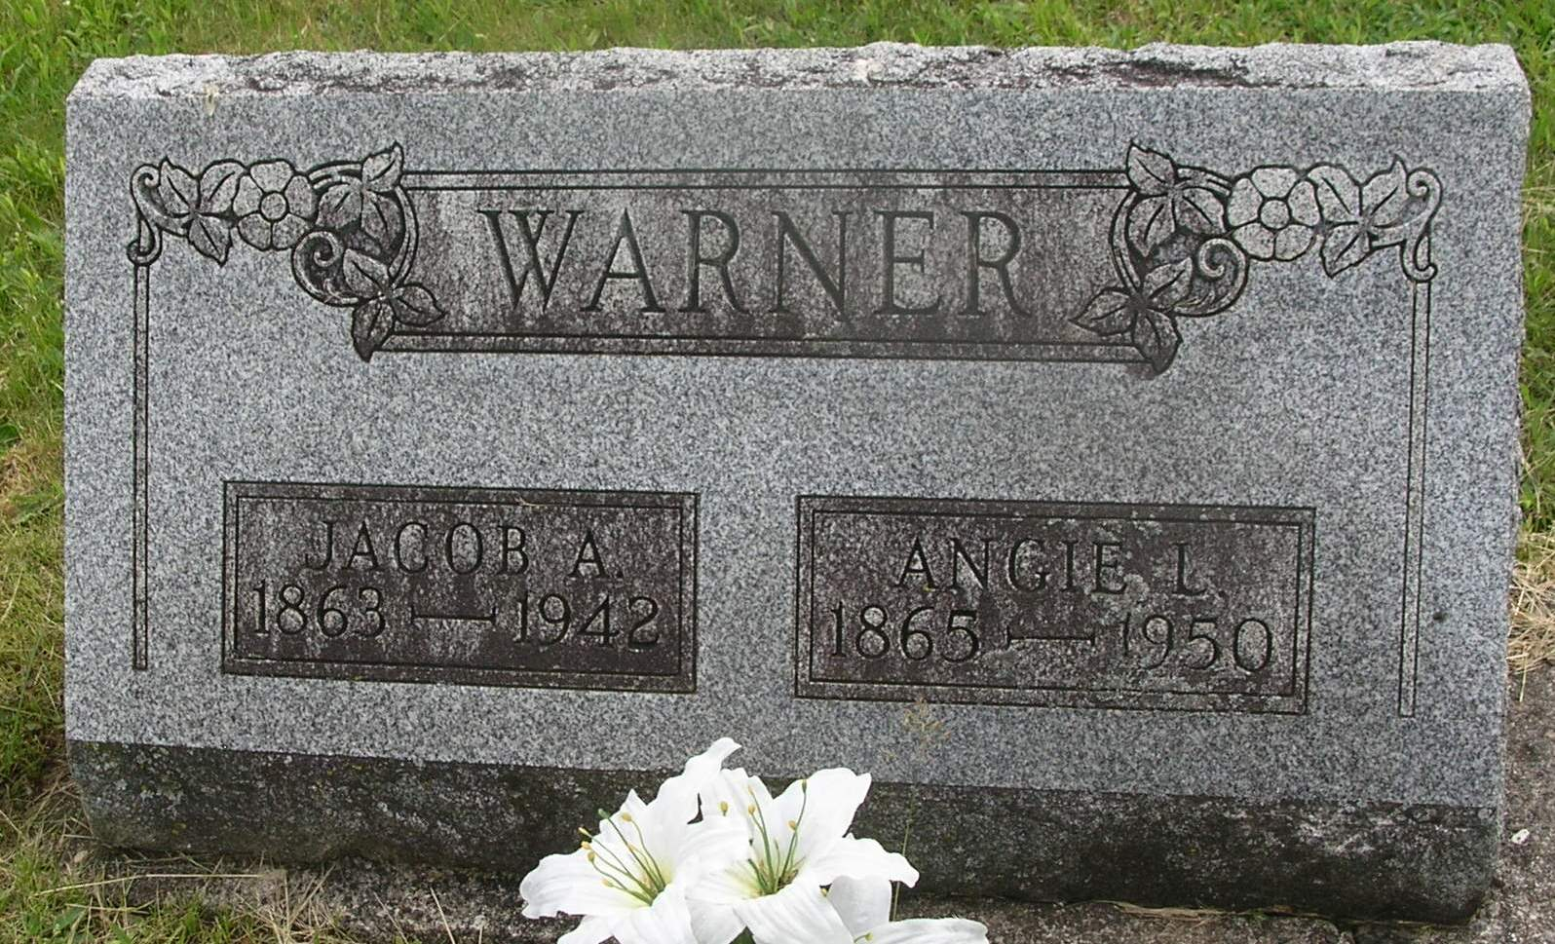

Jacob A Warner
in the Indiana, Death Certificates, 1899-2011
Name: Jacob A Warner
Gender: Male
Race: White
Age: 79
Marital status: Married
Birth Date: 23 Aug 1863
Birth Place: Nottingham Twp Wells, Ind
Death Date: 13 Jul 1942
Death Place: Petroleum, Wells, Indiana, USA
Father: George L Warner
Mother: Susanah Shoemaker
Spouse: Augeline; age 76 years
Informant: Mrs. Warner; Petroleum, Ind.
Burial: July 15, 1942; Gearnand Cem., Petroleum, Ind.

