Jennie (Stout) Smith
September 9, 1881 – June 12, 1910

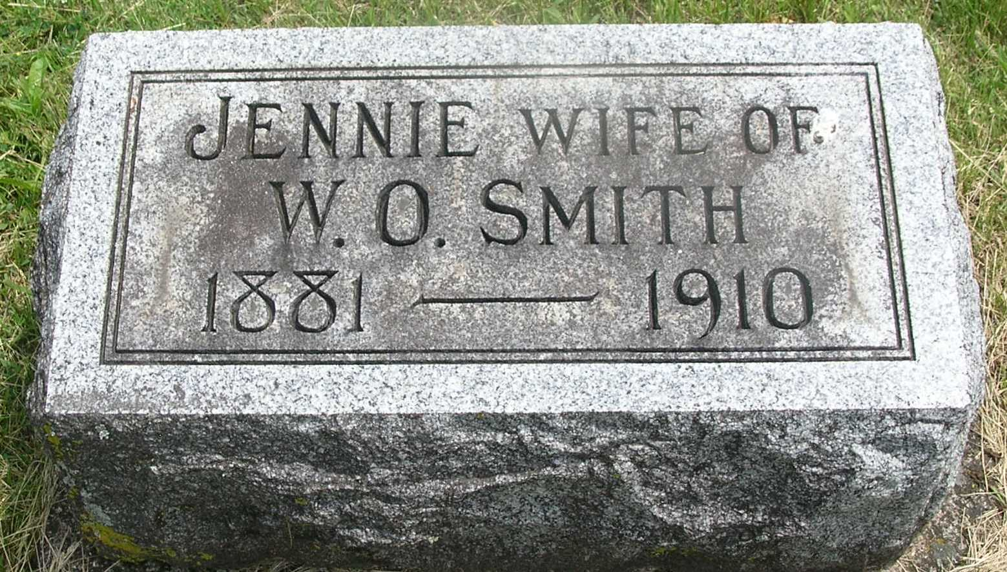

Jennie Stout Smith
in the Indiana, Death Certificates, 1899-2011
Name: Jennie Stout Smith
[Jennie Stout Stout]
Gender: Female
Race: White
Age: 28
Marital status: Married
Birth Date: 9 Sep 1881
Birth Place: Wells Co Ind
Death Date: 12 Jun 1910
Death Place: Harrison, Wells, Indiana , USA
Father: Wm C Stout
Mother: Eliza Ellen Moyer
Spouse: Wm O. Smith
Informant: W. O. Smith; Reiffsburg, Ind.
Burial: June 14, 1910; Garnandeen Cem.

