Mary Elizabeth (Gearnand) Shoemaker
May 12, 1866 – July 11, 1948

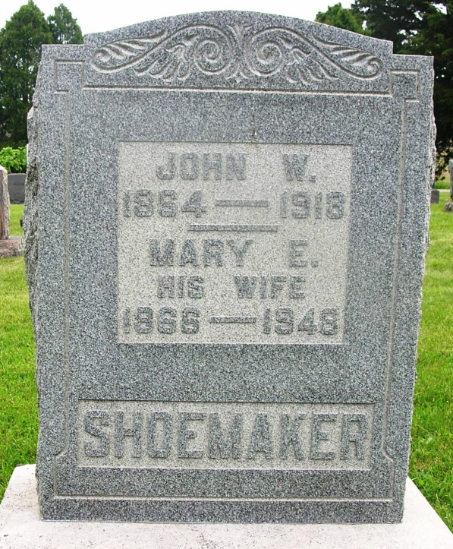

Mary Elizabeth Gernard Shoemaker
in the Indiana, Death Certificates, 1899-2011
Name: Mary Elizabeth Gernard Shoemaker
[Mary Elizabeth Gernard Fernand]
Gender: Female
Race: White
Age: 82
Marital status: Widowed
Birth Date: 12 May 1866
Birth Place: Blackford Co Indiana
Death Date: 11 Jul 1948
Death Place: Bluffton, Wells, Indiana , USA
Father: Floyd G Gernand
Mother: Elizabeth Householder
Spouse: John William Shoemaker
Informant: Mrs. Minnie M. King
Burial: July 12, 1948; Gernand Cem.

