Lovina (Nash) Shoemaker
January 26, 1827 – March 11, 1893

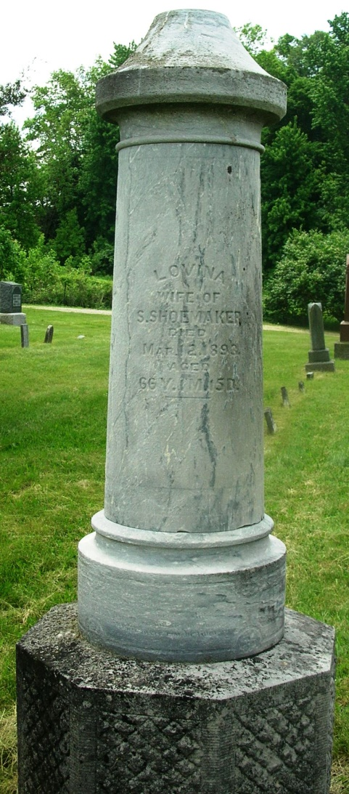

Leviner Shoemaker
in the Indiana, WPA Death Index, 1882-1920
Name: Leviner Shoemaker
[Lavina Shoemaker ]
Date: 11 Mar 1893
Location: Wells County
Age: 66 Yr
Gender: Female
Race: White
Source Location: County Health Office, Bluffton
Source Notes: The source of this record is the book H-14 on page 56 within the series produced by the Indiana Works Progress Administration.

