Harry John Shoemaker
April 26, 1906 – May 6, 1943

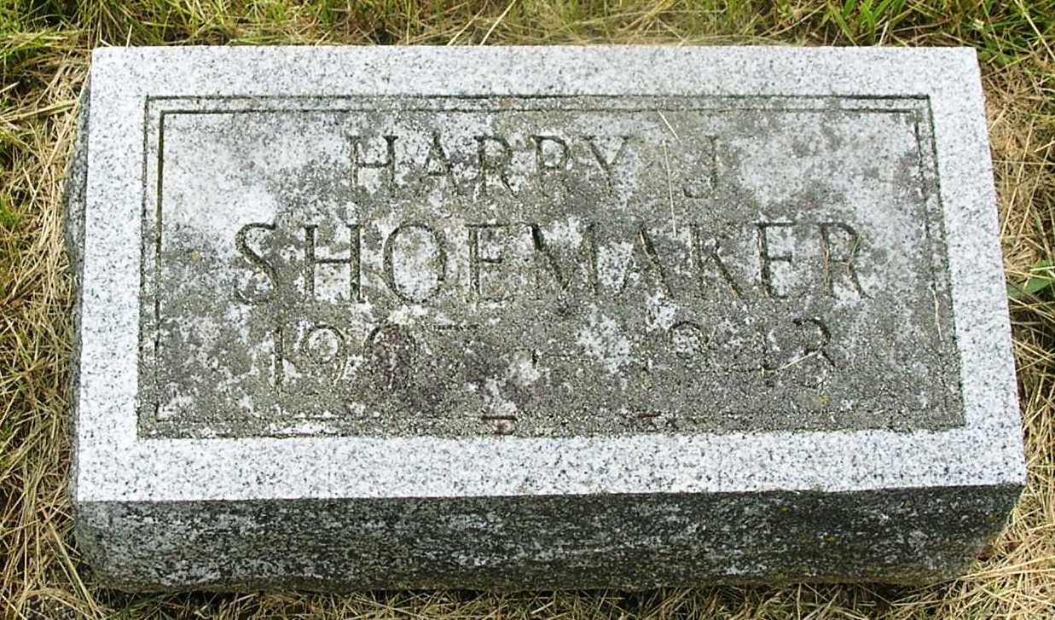

Harry Shoemaker
in the Indiana, Death Certificates, 1899-2011
Name: Harry Shoemaker
Gender: Male
Race: White
Age: 37
Marital status: Single
Birth Date: 26 Apr 1906
Birth Place: Nottingham Twp Wells Co Ind
Death Date: 6 May 1943
Death Place: Bluffton, Wells, Indiana , USA
Father: John W Shoemaker
Mother: Mary Gernanand
Informant: Mrs. Fred King; Bluffton, Ind.
Burial: May 8, 1943; Gernannand Cem.

