Leah (Bower) Risser
October 29, 1814 – April 2, 1903

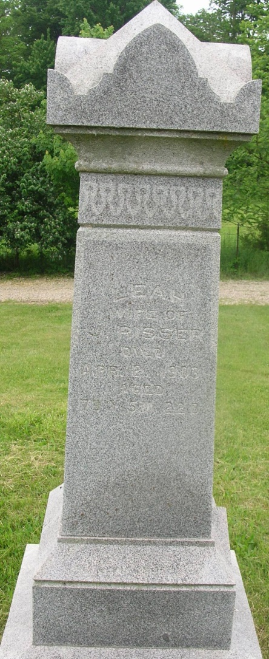

MRS. RISSER DIED THURSDAY EVE
Was One of the Early Settlers of Wells County and Lived to a Ripe Old Age

Mrs. Leah Risser died at the home of her youngest daughter, Mrs. Jacob Warner, last Thursday at five o'clock. Mrs. Risser had been confined to the house for some time and the cause of her death was complication of diseases incident to old age, she being seventy-four.
Mrs. Risser was the wife of the late Joseph Risser, who died in 1896, and was the mother of seven children, four of whom, W. H. and S. B. Risser and Emma L. Books and Angeline Warner are living, and were at her bedside when the death summons came.
She, with her husband, came to Wells County from Circleville, Ohio, in the early days, and was instrumental in helping to change things from a howling wilderness to a place of civilization. Mrs. Risser was a member of the Air Line Methodist Church.
Funeral cortege left the house Saturday at one o'clock and the sermon was preached at the Reiffsburg Church. Interment in the Granand Cemetery.

Bluffton Banner, Wells County, Indiana
(a weekly newspaper)
Wednesday, April 8, 1903
*****
Indiana, Death Certificates, 1899-2011
Name: Leah Risser
[Leah Bowen]
Gender: Female
Race: White
Age: 64 years, 6 months, 8 days [sic]
Marital status: Widow
Birth Date: 10 Oct 18?9
Birth Place: Penn
Death Date: 2 Apr 1903
Death Place: Nottingham, Wells, Indiana , USA
Father: Simon Bowen
Spouse: Joseph Risser
Informant: Family
Burial: April 4, 1903; Gournan Cem.

