Joseph Risser
April 1, 1830 – March 28, 1896

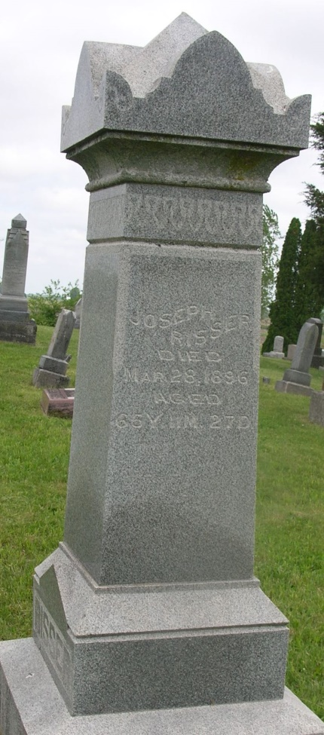

Joseph Risser
in the Indiana, WPA Death Index, 1882-1920
Name: Joseph Risser
Date: 28 Mar 1896
Location: Wells County
Age: 65 Yr
Gender: Male
Race: White
Source Location: County Health Office, Bluffton
Source Notes: The source of this record is the book H-14 on page 120 within the series produced by the Indiana Works Progress Administration.

