Amos Reiff
September 20, 1827 – October 29, 1906

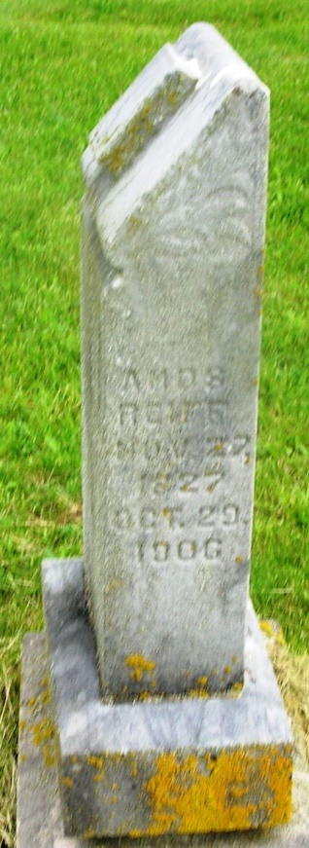

Amos Reiff
in the Indiana, Death Certificates, 1899-2011
Name: Amos Reiff
Gender: Male
Race: White
Age: 79
Marital status: Married
Birth Date: 20 Sep 1827
Birth Place: Ohio
Death Date: 29 Oct 1906
Death Place: Harrison Twp., Wells, Indiana, USA
Spouse: Margant
Informant: William Barton; Poneto, Ind.
Burial: Oct. 31, 1906; Garnand Cem.

