Lydia Ann (Warner) Pence
May 20, 1851 – July 8, 1938

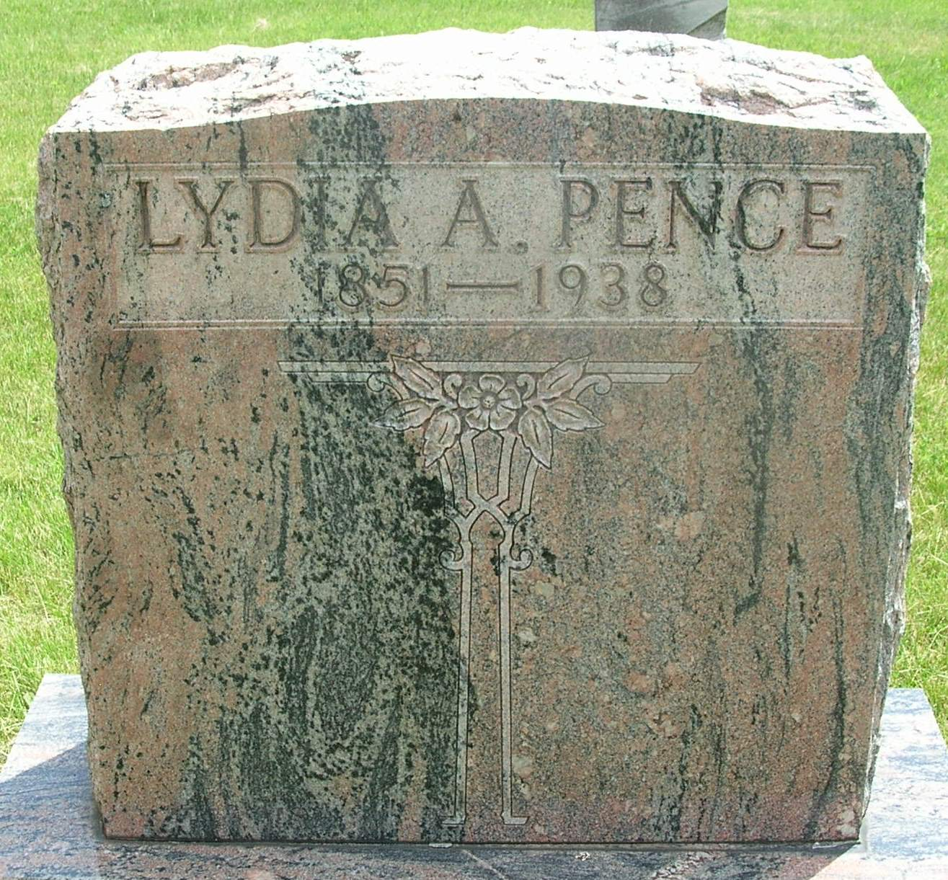

Lydia Ann Pence
in the Indiana, Death Certificates, 1899-2011
Name: Lydia Ann Pence
[Lydia Ann Warner]
Gender: Female
Race: White
Age: 87
Marital status: Widowed
Birth Date: 20 May 1851
Birth Place: Walls Co Ind
Death Date: 8 Jul 1938
Death Place: Bluffton, Wells, Indiana , USA
Father: John Warner
Spouse: Peter Pence
Informant: Fred Pence; Pamona, Calif.
Burial: July 10, 1938; Gernnand Cem.

