Fremont O’Dell
March 28, 1864 – February 16, 1900

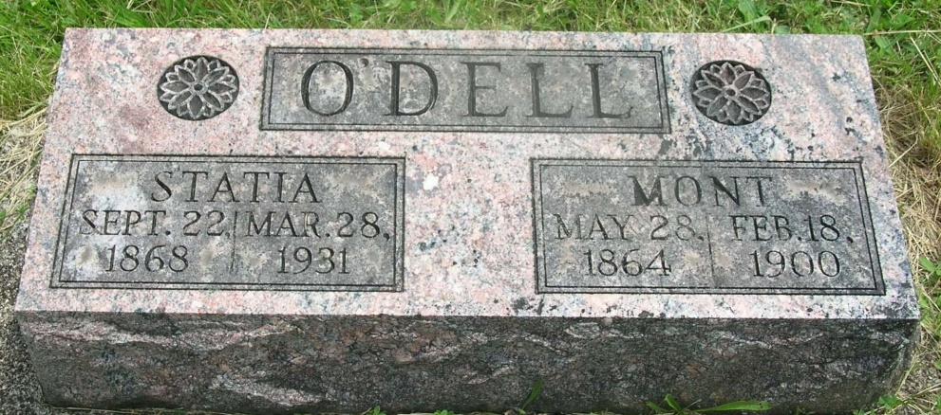

Fremont Odell
in the Indiana, Death Certificates, 1899-2011
Name: Fremont Odell
Gender: Male
Race: White
Age: 35 years, 10 months, 19 days
Birth Date: abt 1865
Birth Place: Wells Co
Death Date: 16 Feb 1900
Death Place: Petroleum, Wells, Indiana, USA
Father: James Odell
Mother: Docia Thornburg
Informant: Sam Groves; Bluffton, Ind.
Burial: Feb. 18, 1900; Rieffburg Cem.

