James Archer Myers
May 25, 1880 – December 8, 1852

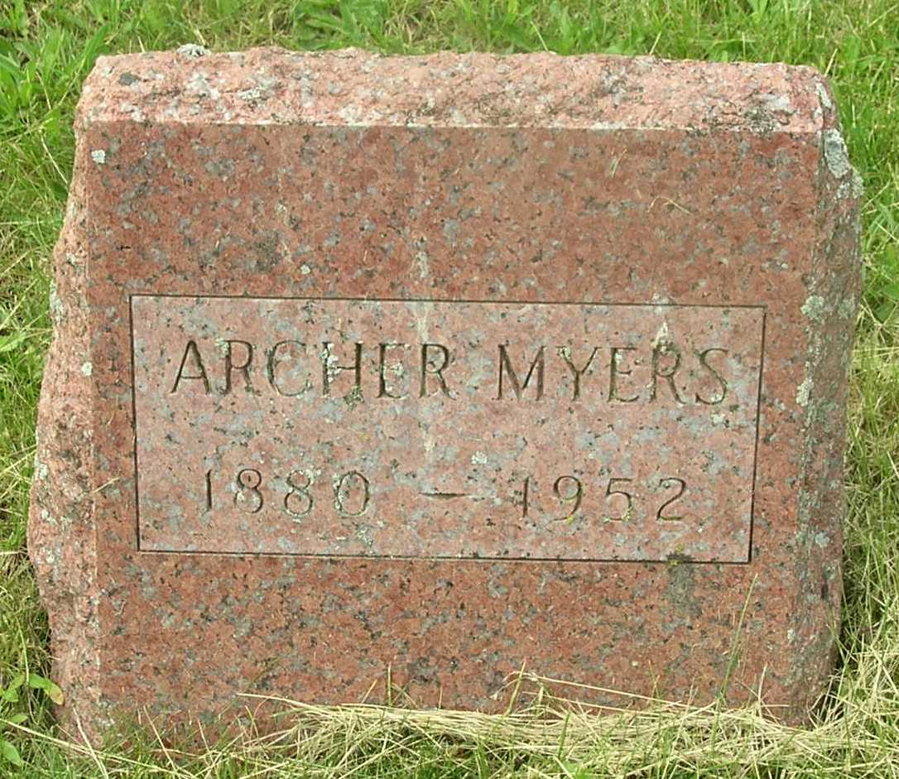

James Archer Myers
in the Indiana, Death Certificates, 1899-2011
Name: James Archer Myers
Gender: Male
Race: White
Age: 72
Marital status: Never Married (Single)
Birth Date: 25 May 1880
Birth Place: Indiana
Death Date: 8 Dec 1952
Death Place: Bluffton, Wells, Indiana , USA
Father: Jesse C Myers
Mother: Josephina Louis
Informant: Garth Dyson; Bluffton, Ind.
Burial: Dec. 10, 1952; Garnand Cem., Wells Co., Ind.

