Ida (Gardenour) Myers
February 10, 1854 – February 27, 1903

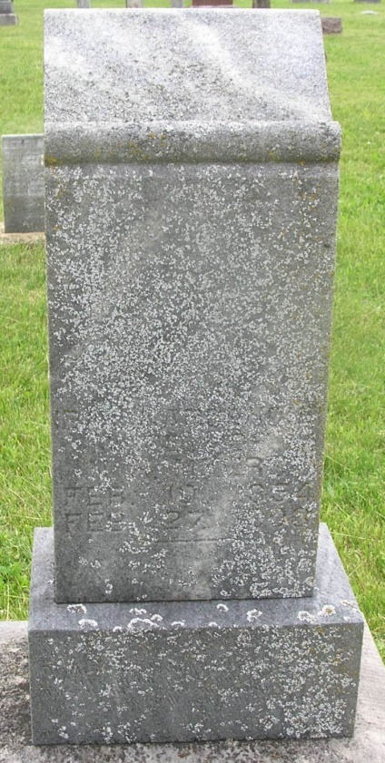

Mrs. Ida Myers, wife of Nathaniel Myers, was called to her eternal resting place Friday afternoon by her creator. She died at half past five at the age of forty-nine years.
The funeral services were held at the house Sunday morning at ten o'clock and the burial will [sic] took place in the Gernand Cemetery.

Bluffton Banner, Wells County, Indiana
(a weekly newspaper)
Wednesday, March 4, 1903
*****
Indiana, Death Certificates, 1899-2011
Name: Ida Myers
[Ida Gardenour]
Gender: Female
Race: White
Age: 49
Marital status: Married
Birth Date: abt 1854
Birth Place: Wells Co Indiana
Death Date: 27 Feb 1903
Death Place: Harrison, Wells, Indiana , USA
Father: Joseph Gardenour
Mother: Ellen Dewitt
Spouse: N H Myers
Informant: Family; Bluffton, Ind.
Burial: March 1, 1903; Garnand Cem.

