Kenneth L. McVoy
April 23, 1922 – February 10, 1944

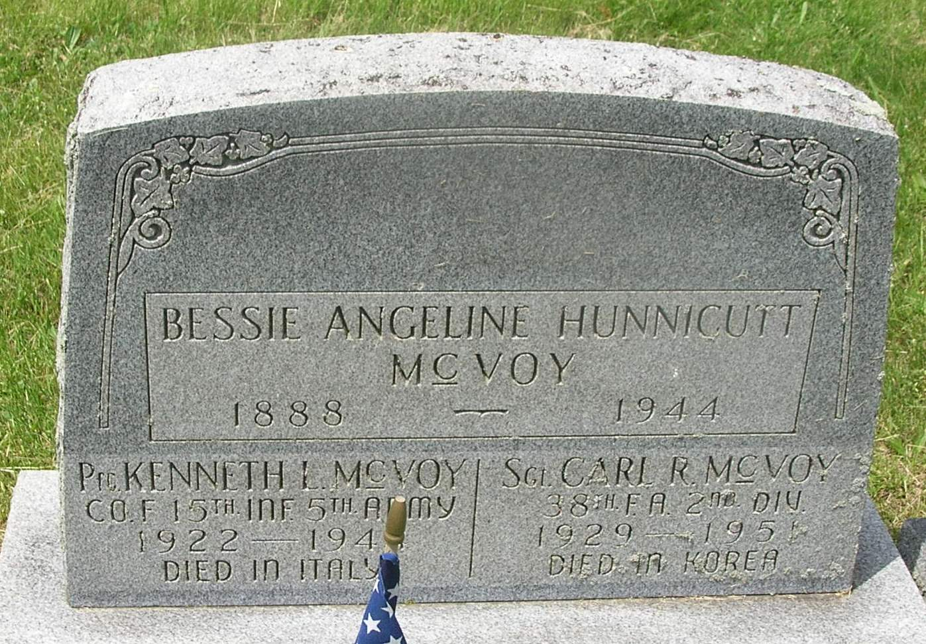

U.S., Department of Veterans Affairs BIRLS Death File, 1850-2010
Name: Kenneth McVoy
Gender: Male
Birth Date: 23 Apr 1922
Death Date: 10 Feb 1944
SSN: 312148073
Branch 1: ARMY
Enlistment Date 1: 2 Apr 1943
Release Date 1: 10 Feb 1944
*****
U.S. Rosters of World War II Dead, 1939-1945
Name: Kenneth L Mcvoy
Gender: Male
Race: White
Religion: Protestant
Cemetery Name: Nettuno (Permanent Cemetery), Nettuno, Italy
Grave Number: F 6 14
Disposition: According to next of kin
Service Branch: Army
Rank: Private First Class
Service Number: 35140039

