Susan (Myers) Leist
April 2, 1855 – July 14, 1931

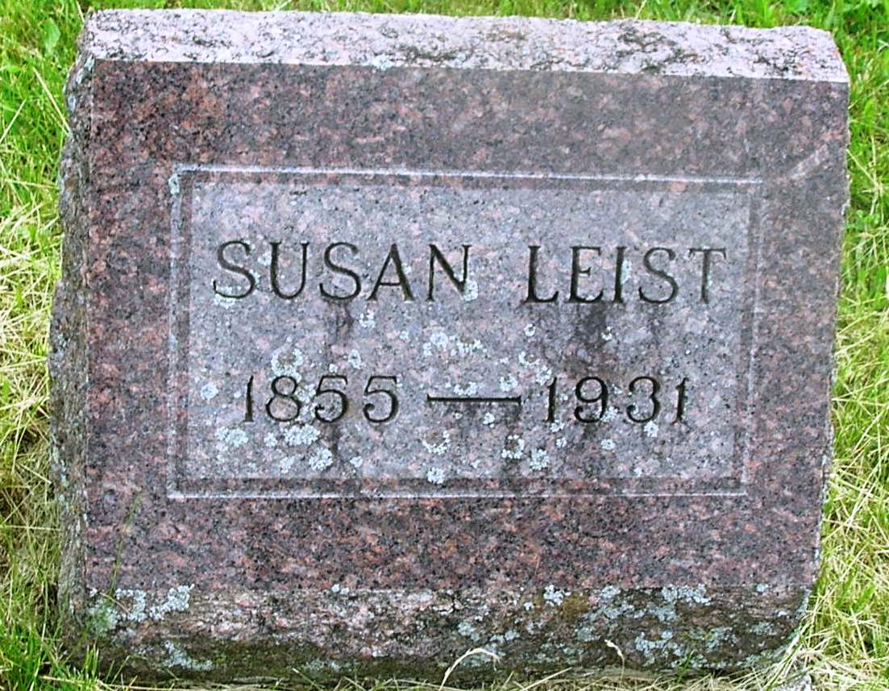

Susan Leist
in the Indiana, Death Certificates, 1899-2011
Name: Susan Leist
[Susan Myers]
Gender: Female
Race: White
Age: 76
Marital status: Widow
Birth Date: 2 Apr 1855
Birth Place: Wells Co., Indiana
Death Date: 14 Jul 1931
Death Place: Bluffton, Wells , Indiana, USA
Father: Michael Myers
Mother: Susan Hall
Spouse: George Leist (deceased)
Informant: Arlie Leist; Bluffton, Ind.
Burial: July 17, 1931; Garnan Cem.

