Arlie I. Leist
March 12, 1884 – October 27, 1965

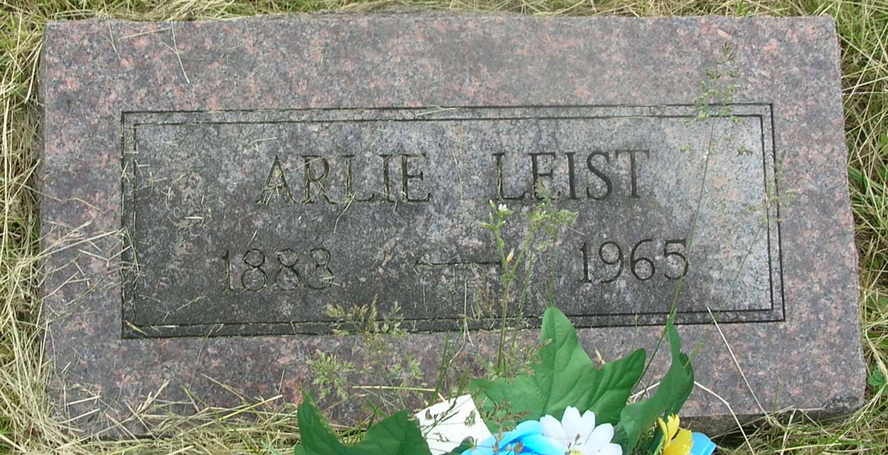

Arlie I Leist
in the Indiana, Death Certificates, 1899-2011
Name: Arlie I Leist
Gender: Male
Race: White
Age: 81
Marital status: Never Married (Single)
Birth Date: 12 Mar 1884
Birth Place: Indiana
Death Date: 27 Oct 1965
Death Place: Clinic Hospital, Wells, Indiana, USA
Father: George Leist
Mother: Susan Muers
Informant: Mrs. Sylvia Leist; Niece; Poneto, Ind.
Burial: Oct. 29, 1965; Grenand Cem., Wells Co.

