Fred Jines
October 24, 1912 – February 28, 1999

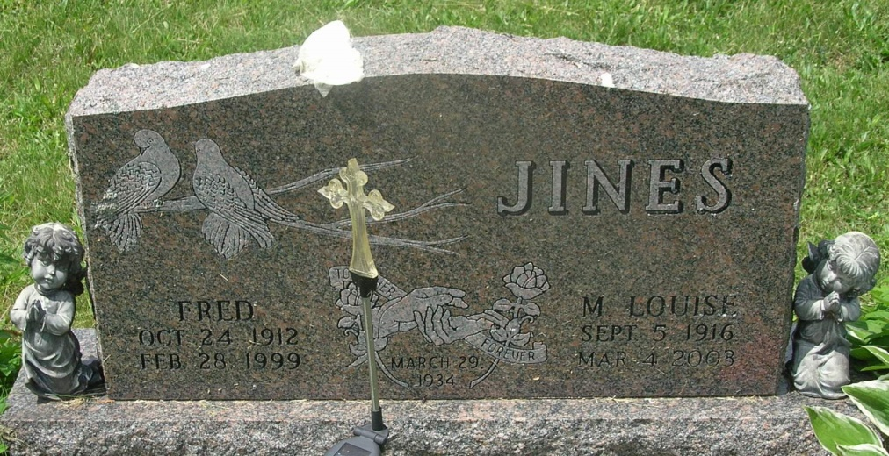

Fred Jines, 86
Formerly of 1512 West Cherry St., Fred Jines, 86, of Buffalo Valley, Tenn., died Friday afternoon at Carthage Memorial Hospital in Carthage, Tenn., following a two-year illness.
Mr. Jines was born Oct. 24, 1912 in Greenville, Mo. to William R. and Cora Haynes Jines. His marriage to Mable Compton took place March 29, 1934 in Mt. Vernon, Ill. They renewed their wedding vows in 1998 on their 63rd wedding anniversary in Tazwell, Tenn.
Mr. Jines was a carpenter for over 30 years, having worked for Herman Reiff and Walter Claghorn as well as Ivan Frauhiger Contractors.
Surviving in addition to the wife are one son, Daniel Jines, of Andrews; four daughters, Betty Louise Jines and Dena Odel Hutton, both of Buffalo Valley, Tenn., Peggy A. Blevins of Bluffton and Mrs. Fallas (Freda) Seals, of St. Charles, Va.; 31 grandchildren, 37 great-grandchildren and eight great-great grandchildren.
Mr. Jines was proceeded in death by three daughters, June, Dorothy and Freida and one son, Donald.
Services will be held Tuesday at 10:30 a.m. at Thoma/Rich, Hewitt & Chaney Funeral Home with Rev. James Poling officiating. Calling will be from 2 p.m. until 8 p.m. Monday at the funeral home. Burial will be in the Gearnand Cemetery.
Memorials are to be made to St. Jude Hospital.

Thoma/Rich, Hewitt & Chaney Funeral Home, Wells County, Indiana
March 1, 1999

