William Huss
February 13, 1851 – October 18, 1921

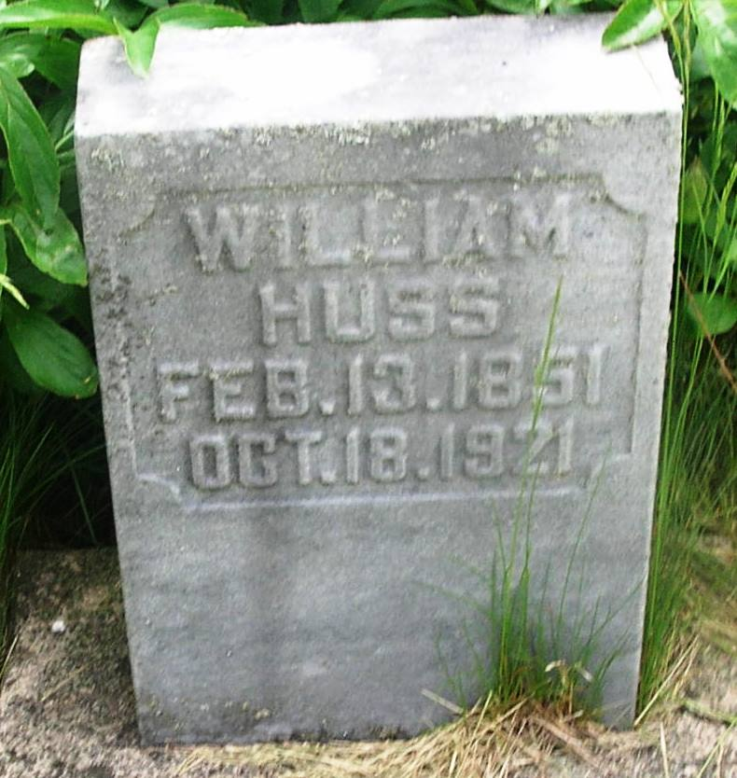

Wiliam Huss
in the Indiana, Death Certificates, 1899-2011
Name: William Huss
Gender: Male
Race: White
Age: 70
Marital status: Single
Birth Date: 13 Feb 1851
Birth Place: Wells Co., Ind.
Death Date: 18 Oct 1921
Death Place: Nottingham, Wells, Indiana , USA
Father: Elisha Huss
Mother: Mahala Bennett
Informant: Sarah Huss; Reiffsburg, Ind.
Burial: Oct. 19, 1921; Garnand Cem.

