Paul A. Huss
February 23, 1914 – June 3, 1978

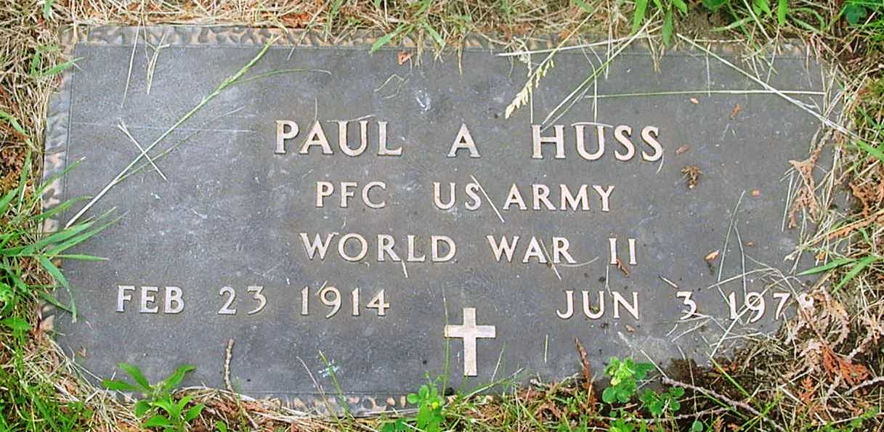

Paul A Huss
in the Indiana, Death Certificates, 1899-2011
Name: Paul A Huss
Gender: Male
Race: White
Age: 64
Marital status: Married
Birth Date: 23 Feb 1914
Birth Place: Indiana
Death Date: 3 Jun 1978
Death Place: Bluffton, Wells, Indiana , USA
Father: Jacob Huss
Mother: Jenny Shannon
Spouse: Marjorie Stoner
Informant: Marjorie Huss; Bluffton, Ind.
Burial: June 5, 1978; Granand Cem., Bluffton, Ind.

