Florence May Huss
March 24, 1903 – October 9, 1903

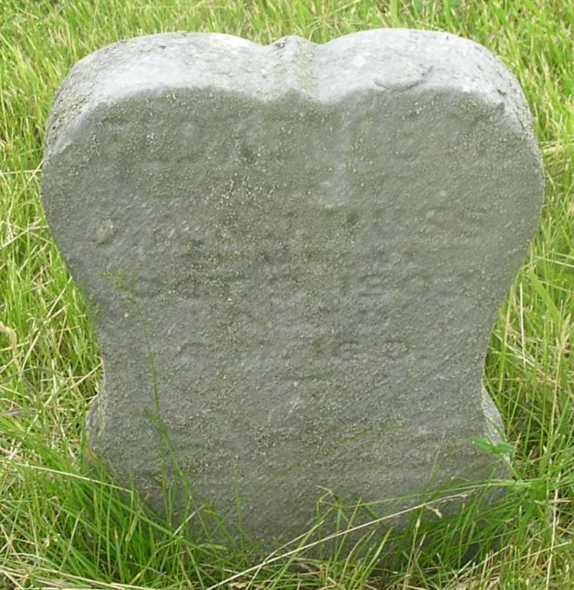

The five week's old daughter of Mr. and Mrs. Jacob Huss, of Reiffsburg, died Thursday night. The interment took place at Garnand's Cemetery Saturday morning at ten o'clock.

Bluffton Banner, Wells County, Indiana
(a weekly newspaper)
Wednesday, Oct. 14, 1903

*****
Florence May Hass
in the Indiana, Death Certificates, 1899-2011
Name: Florence May Huss
Gender: Female
Race: White
Age: 4 months
Marital status: Single
Birth Date: abt 1903
Birth Place: Ind
Death Date: 9 Oct 1903
Death Place: Harrison, Wells, Indiana, USA
Father: Jacob Huss
Mother: Jennie Shannon
Burial: Oct. 10, 1903; Garnand Cem.

