Nancy (Householder) Houdyshell
May 8, 1825 – September 14, 1902

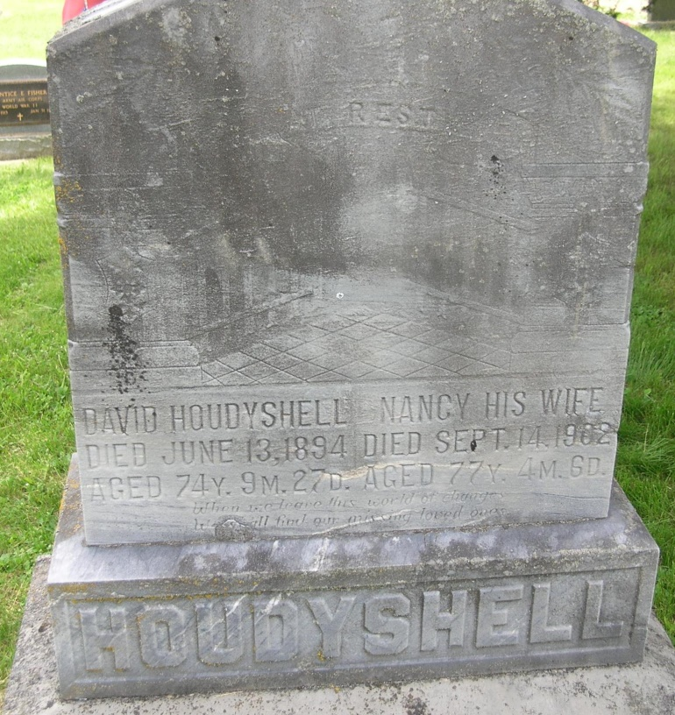

Nancie Houdyshell
in the Indiana, Death Certificates, 1899-2011
Name: Nancie Houdyshell
[Nancie Householder]
Gender: Female
Race: White
Age: 77
Marital status: Widowed
Birth Date: 8 May 1825
Birth Place: Fairfield Co Ohio
Death Date: 14 Sep 1902
Death Place: Nottingham, Wells, Indiana, USA
Father: Philip Householder
Mother: Mary
Spouse: David Houdyshell
Informant: William Houdyshell; Ruth, Ind.
Burial: Sept. 15, 1902; Gernand Cem.

