Sarah Cordelia (Newhouse) Holloway
October 28, 1850 – May 25, 1921

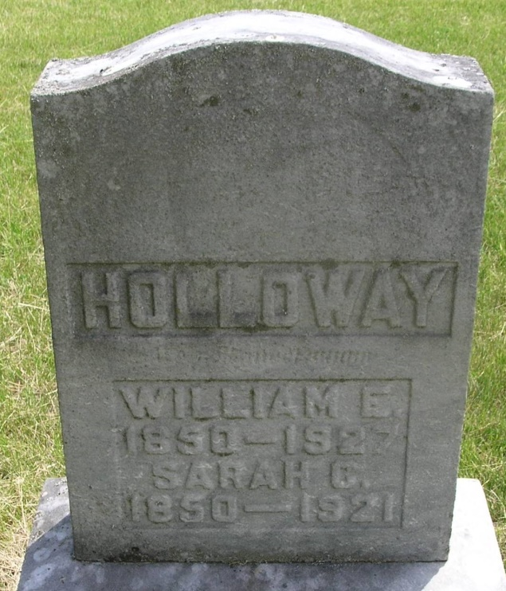

Sarah Codelia Halloway
in the Indiana, Death Certificates, 1899-2011
Name: Sarah Cordelia Holloway
[Sarah Codelia Newhouse]
Maiden Name: Hallowaw
Gender: Female
Race: White
Age: 70
Marital status: Married
Birth Date: 28 Oct 1850
Birth Place: Indiana
Death Date: 25 May 1921
Death Place: Nottingham, Wells, Indiana , USA
Father: John Newhouse
Mother: Emily Koon
Spouse: William Holloway
Informant: William Holloway; Petroleum, Ind.
Burial: May 29, 1921; Grenan Cem., Wells Co.

