John Edward Hamilton
May 10, 1865 – July 11, 1955

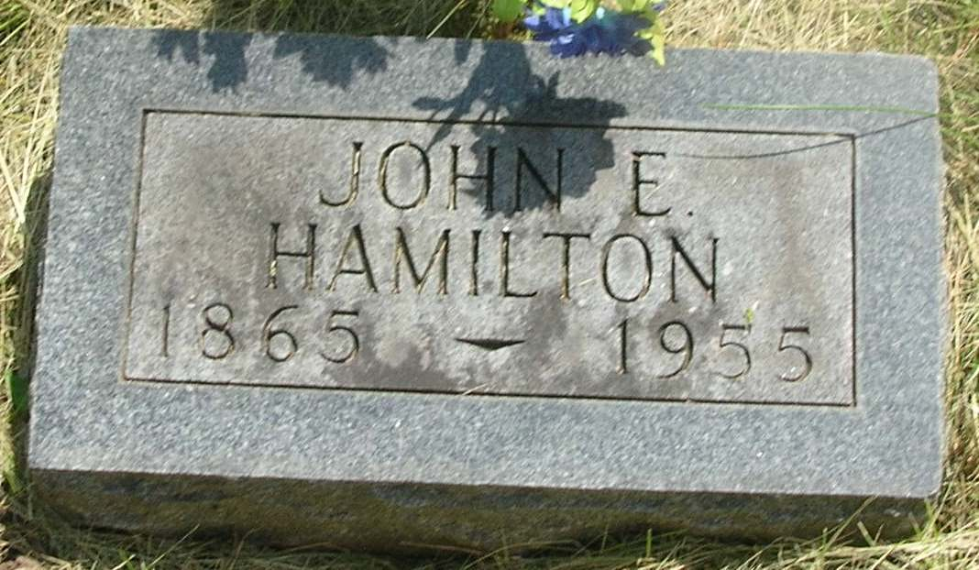

John Edward Hamilton
in the Indiana, Death Certificates, 1899-2011
Name: John Edward Hamilton
Gender: Male
Race: White
Age: 90
Marital status: Widowed
Birth Date: 10 May 1865
Birth Place: Indiana
Death Date: 11 Jul 1955
Death Place: Rural, Wells, Indiana , USA
Father: John Hamilton
Mother: Elizabeth Nute
Informant: Mrs. Cecile Roberts; Poneto, Ind.
Burial: July 13, 1955; Gernand Cem., Wells Co., Ind.

