Sherman Frank Gearnand
July 6, 1902 – January 5, 1919

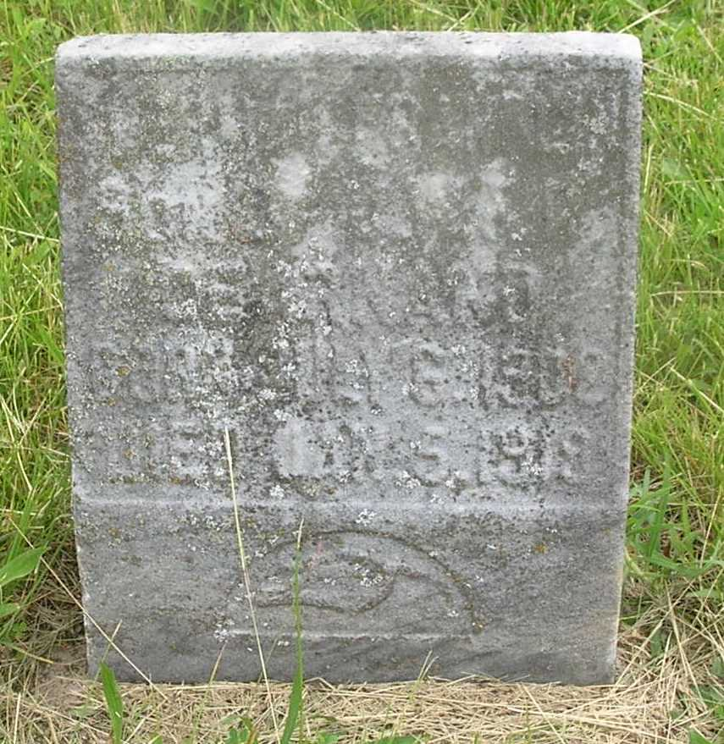

Indiana, Death Certificates, 1899-2011

Name: Sherman Frank Gearnand
Gender: Male
Race: White
Age: 16y 5m 29d
Marital status: Single
Birth Date: 6 Jul 1902
Birth Place: Wells Co Indiana
Death Date: 5 Jan 1919
Death Place: Reiffsburg, Wells, Indiana, USA
Father: Jasper Gearnand
Mother: Rhoda King
Informant: Family
Burial: 1/7/1919, Gearnand Cem

