Cloey Ethel (Books) Franks
February 28, 1889 – December 10, 1914
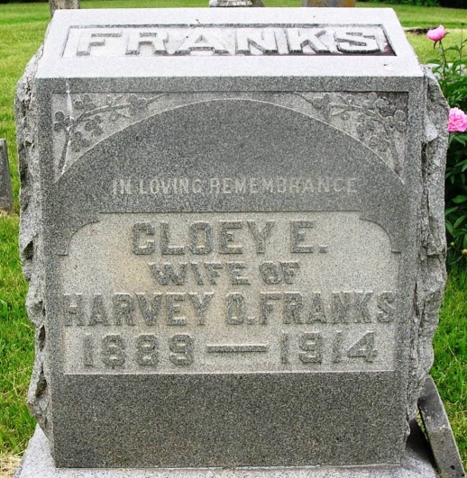
Cloey Ethel Franka
in the Indiana, Death Certificates, 1899-2011
Name: Cloey Ethel Franks
[Cloey Ethel Books]
Gender: Female
Race: White
Age: 25
Marital status: Married
Birth Date: 28 Feb 1889
Birth Place: Jay Co Ind
Death Date: 10 Dec 1914; ectopic gestation
Death Place: Petroleum, , Indiana , USA
Father: John Books
Mother: Rebeca Priest
Spouse: Harvey O. Franks
Informant: Harvey Franks; Petroleum, Ind.
Burial: Dec. 11, 1914; Gearnand Cem., Petroleum

