Clellah (King) Fisher
March 1, 1910 – July 2, 2003
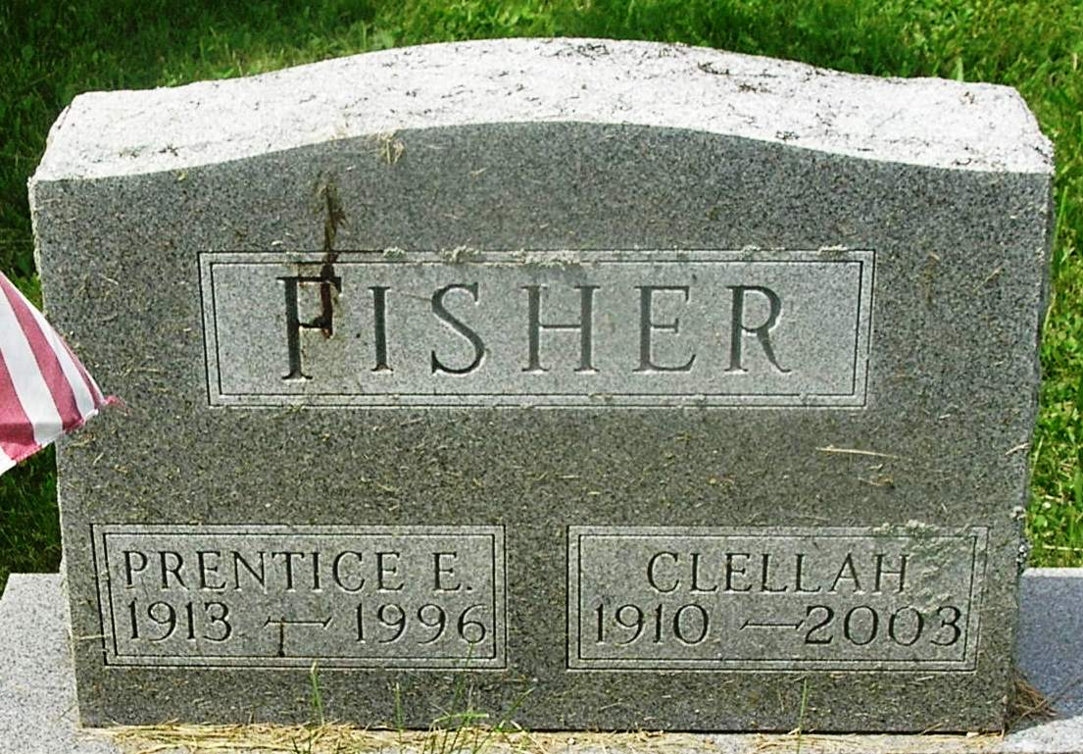
Clellah Fisher, 93
Clellah Fisher, 93, a lifetime resident of Wells County, died at 5:55 p.m. Wednesday, July 2, at Meadowvale Health & Rehab Center in Bluffton where she had resided the last two years.
Although a homemaker for most of her life, Mrs. Fisher was engaged as a practical nurse for five years at the Ballmont Hospital in Royal Oak, Mich.
She was born in Wells County March 1, 1910, a daughter of Fred and Minnie "Myrtle" Shoemaker King. Her marriage in Pontiac, Mich., on Jan. 31, 1942 was to Prentice E. Fisher, who died Jan. 31, 1996.
Surviving are a son, Prentice King of Bluffton; a sister, Ruby Kemple of Bluffton; a brother-in-law Ralph McBride of Fort Wayne; and several nieces and nephews. A sister is deceased.
Calling hours at the Thoma/Rich, Hewitt & Chaney Funeral Home will be Saturday from 10 a.m. until time for services at 2:30 p.m.
Rev. Neil Wilson will officiate and burial will be in Gearnand Cemetery.
Memorials to the donor's choice.
Bluffton News Banner, Wells County, Indiana
July 3, 2003
*****
Indiana, Death Certificates, 1899-2011
Name: Clellah Fisher
[Clellah King]
Gender: Female
Race: White
Age: 93
Marital status: Widowed
Birth Date: 1 Mar 1910
Birth Place: Wells County, Indiana
Death Date: 2 Jul 2003
Death Place: Bluffton, Wells, Indiana , USA
Father: Fred King
Mother: Minnie Myrtle Shoemaker
Informant: Prentice King; nephew; Bluffton, Ind.
Burial: July 5, 2003; Gearnand Cem., Bluffton, Ind.

