Michael W. Brown
November 24, 1957 – December 18, 2005

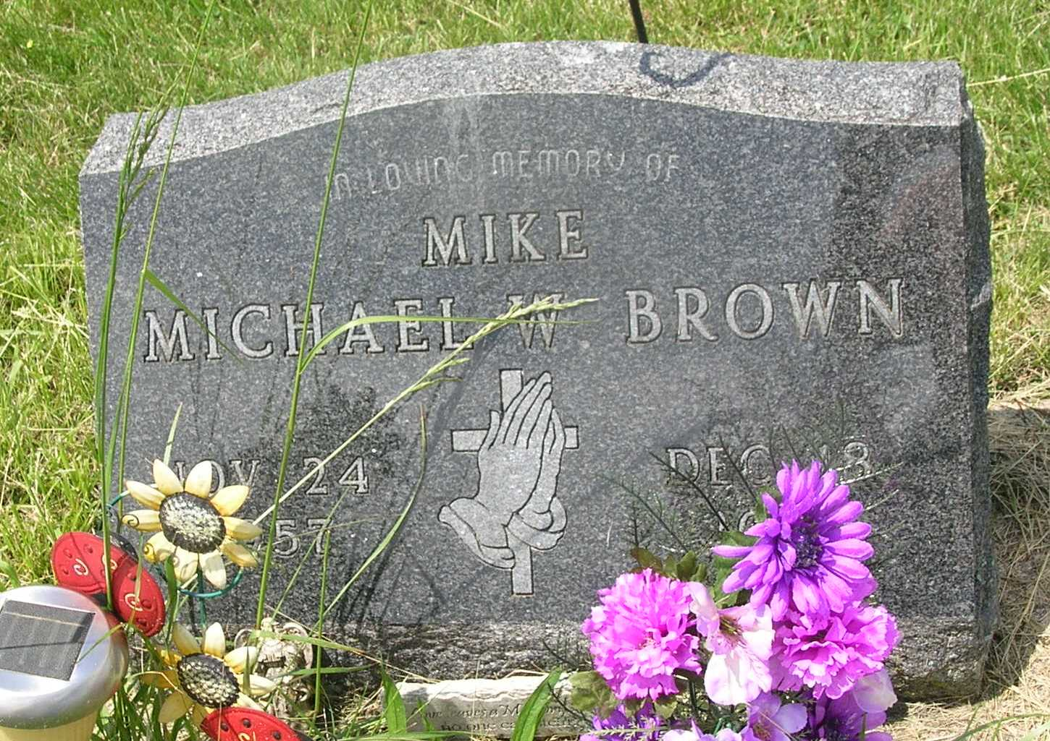

Michael W. Brown, 48
Michael W. "Mike" Brown, 48, died at his residence in Murray following a house fire Sunday, Dec. 18. He was born Nov. 24, 1957 in Wells County to Donald R. and Carolyn Richards Brown, who survive in Portland. He was employed at Wayne Metal in Markle and a lifelong resident of Wells County.
Other survivors include a son, Michael, of Jasper; sisters Connie Connett and Pam Coleman, both of Ossian, Diane Worthington, Etna Green, Christine Ball of Portland, and Debbie Stiles of Bluffton; brothers Daniel and Ronald Brown, both of Bluffton, David and Tom Brown, both of Portland; step-son Hunter Harper of Bluffton and step-daughter Chelsea Harper of Markle. A brother, Steve Brown, preceded him in death.
Services at 1 p.m. Friday will be under the direction of Pastor Theodore Waggoner at Thoma/Rich, Hewitt & Chaney Funeral Home. Calling will be from 2 to 8 p.m. Thursday at the funeral home. Burial will be in Gearnand Cemetery in Wells County
Memorials may be made to the family.

Thoma/Rich Funeral Home, Wells County, Indiana
December 19, 2005

