Donald R. Brown
March 15, 1936 – October 2, 2016

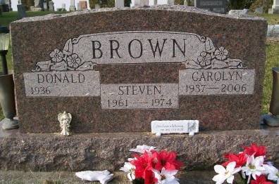
Photo by Scott Shoup
Donald R. Brown, age 80, of Bryant and formerly of Bluffton, passed away Sunday morning, October 2, 2016, at Lutheran Hospital in Fort Wayne.
Born in Somerset, KY, on March 15, 1936, to Harvey and Francis (Young) Brown, Don married Carolyn J. Richards in Montpelier, IN, on July 31, 1955; she preceded him in death on May 14, 2006.
Don served his country as a member of the National Guard and attended the Full Gospel Lighthouse Tabernacle in Dunkirk, IN. He will most be remembered for owning and operating his own produce stand for over 40 years in Bluffton then Fiat, with the majority of that time spent in Bluffton.
Survivors include three daughters, Connie (Larry) Connett of Ossian, Debbie Stiles of Bluffton, and Pam Coleman of Bluffton; four sons, Ron Brown of Roland, OK, David Brown of Bryant, Tom Brown of Bryant, and Daniel (Melissa) Brown of Bluffton; 29 grandchildren, 63 great-grandchildren, and one great great-granddaughter; two sisters, Glenna Burris and Margie Gerber, both of Muncie; and three brothers, Robert Brown of Portland, Wendel Brown of Newton, IL, and Oliver (Rae) Brown of Muncie.
In addition to his wife and parents, Don was preceded in death by two daughters, Diane Worthington and Christine Ball; two sons, Michael and Steven Brown; two sisters, Mary Davis and Joyce Knight; two brothers, William and James Brown; and one granddaughter.
Visitation will be Wednesday, Oct. 5, 2016, from 4:00 until 8:00 PM, at Goodwin – Cale & Harnish Memorial Chapel in Bluffton. Services will be held on Thursday morning, at 10:30 AM, at the funeral home, with one hour of visitation prior to the service. Pastor Bobby Thomas will officiate. Burial will be at Gearnand Cemetery in Reiffsburg.

Unknown source

