Simon Bower
August 30, 1848 – January 13, 1934

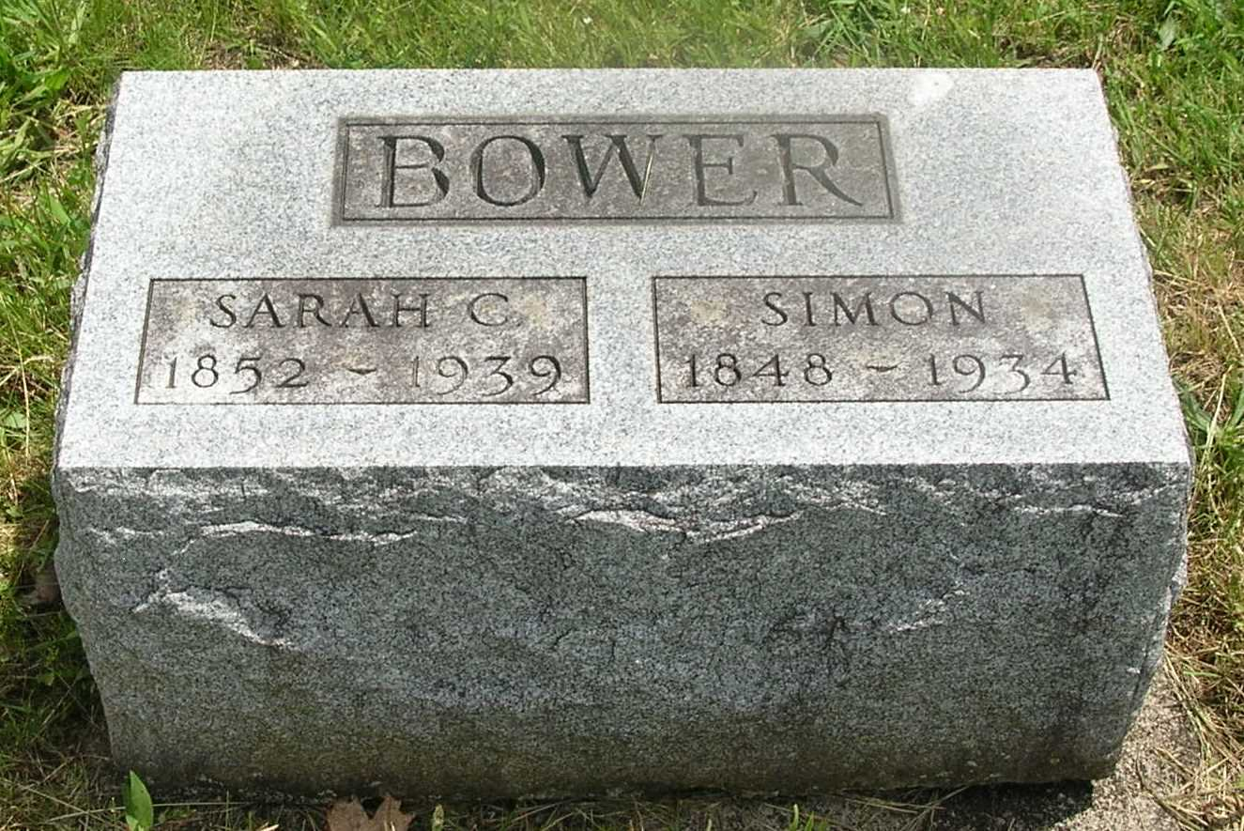

Simon Bower
in the Indiana, Death Certificates, 1899-2011
Name: Simon Bower
Gender: Male
Race: White
Age: 85
Marital status: Married
Birth Date: 30 Aug 1848
Birth Place: Fairfield Co., Ohio
Death Date: 13 Jan 1934
Death Place: Harrison, Wells , Indiana, USA
Father: Joel Bower
Mother: Susan Shoemaker
Spouse: Sarah C. Moyer
Informant: Monroe Bower; Bluffton, Ind.
Burial: Jan. 16, 1934; Gernnand Cem.

