Mary Elizabeth (Speheger) Bower
July 19, 1875 – March 3, 1907

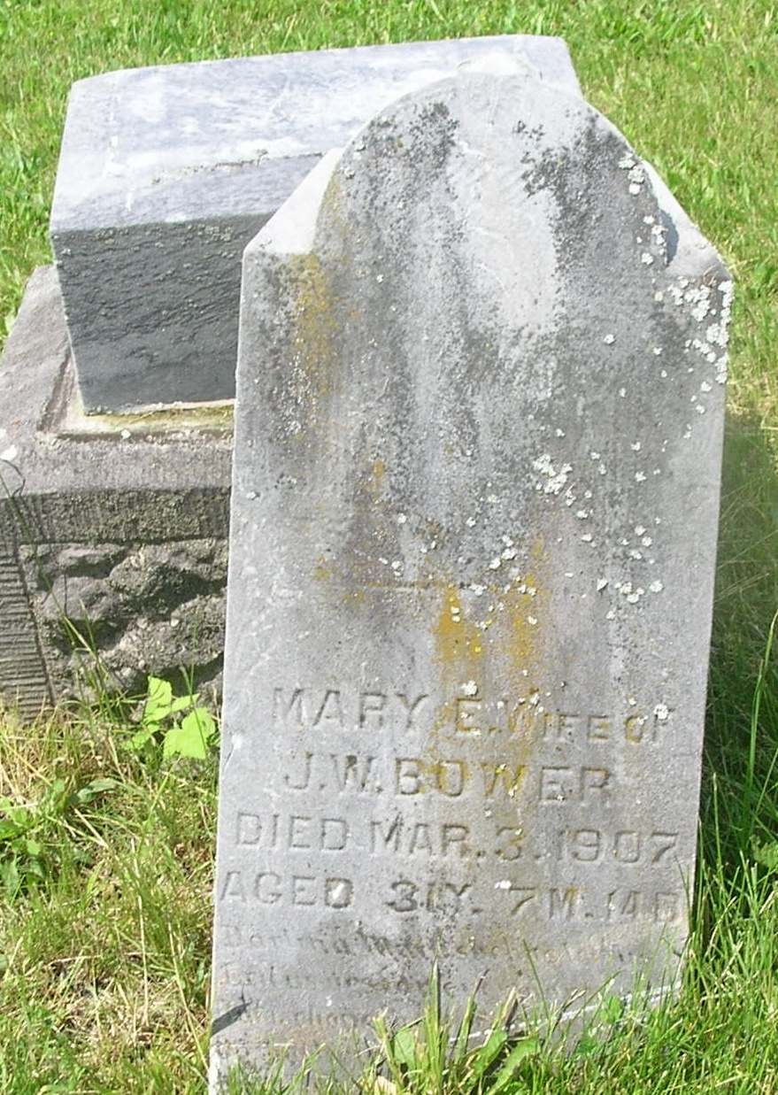

Mary Elizabeth Bower
in the Indiana, Death Certificates, 1899-2011
Name: Mary Elizabeth Bower
Gender: Male
Age: 31
Marital status: Married
Birth Date: 19 Jul 1875
Birth Place: Wayne Co Ohio
Death Date: 3 Mar 1907
Death Place: Nottingham, Wells, Indiana , USA
Father: Abraham Speheger
Mother: Rebecca Tritz
Informant: Abraham Speheger; Bluffton, Ind.
Burial: March 5, 1907; Garnan Cem., Wells Co.

