Joel Bower
September 9, 1824 – January 15, 1896

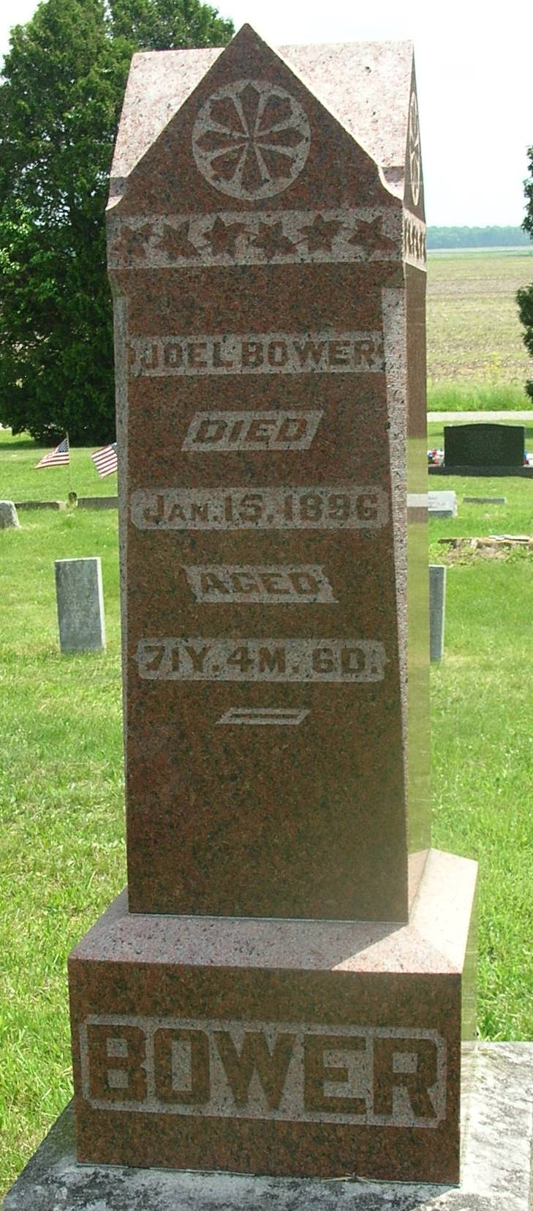

Indiana, WPA Death Index, 1882-1920
Name: Joel Bowers
Date: 15 Jan 1896
Location: Wells County
Age: 72 Yr
Gender: Male
Race: White
Source Location: County Health Office, Bluffton
Source Notes: The source of this record is the book H-14 on page 116 within the series produced by the Indiana Works Progress Administration.
*****
Joel Bower from tree Connett Family Tree
Birth 1825 Somerset, Somerset, Pennsylvania, USA
Marriage 31 Jul 1845 Fairfield, Butler, Ohio, USA
Residence 1880 Wells, Indiana, USA
Death 15 Jan 1896 Wells, Indiana, USA
Father Simon P Bower (1796-1872)
Mother Hannah Ramey (Remey) (1793-1865)
Spouse Susannah / Susan Shoemaker (1826-1889)

