Ruth Anna (Evans) Books
August 1, 1896 – February 17, 1945

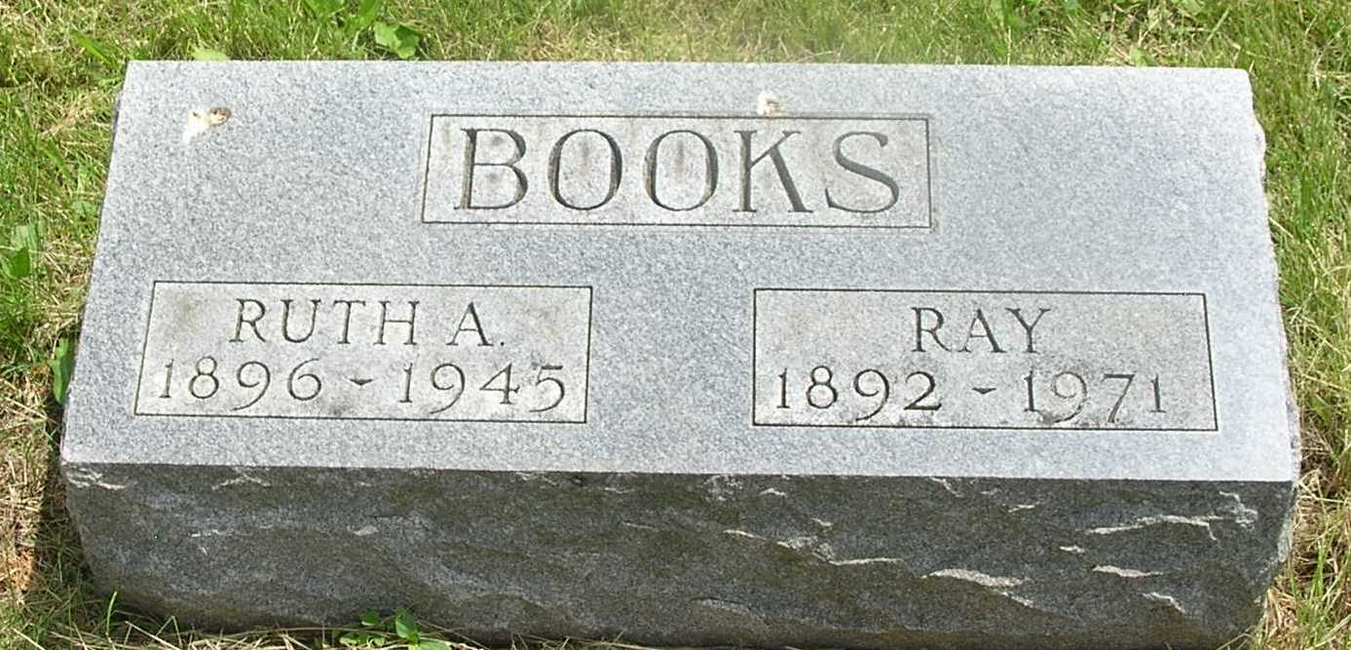

Ruth Anna Books
in the Indiana, Death Certificates, 1899-2011
Name: Ruth Anna Books
[Ruth Anna Eavens]
Gender: Female
Race: White
Age: 48
Marital status: Married
Birth Date: 1 Aug 1896
Birth Place: Jasper Co Ind
Death Date: 17 Feb 1945
Death Place: Ft Wayne, Allen, Indiana, USA
Father: John Eavens
Mother: Lizzie M Bowmen
Spouse: Albert Ray Books; age 53 years
Informant: Albert Ray Books; Ft. Wayne, Ind.
Burial: Feb. 20, 1945; Garnand Cem., Reiffsburg, Ind.

