Andrew Jackson Books
October 20, 1858 – April 28, 1929

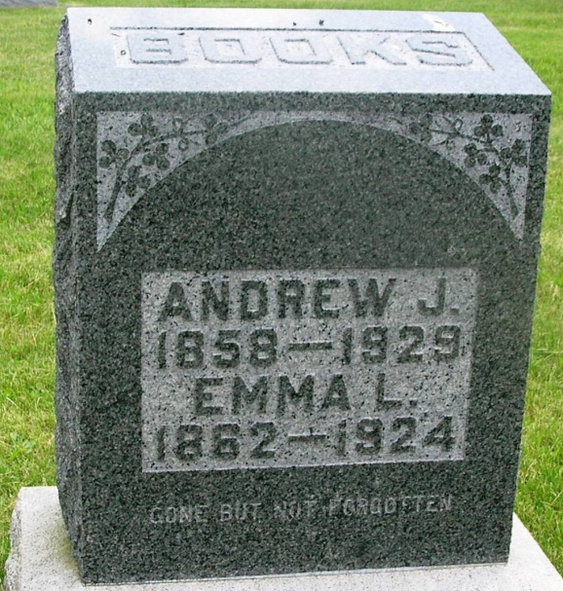

Andrews Jackson Brooks
in the Indiana, Death Certificates, 1899-2011
Name: Andrew Jackson Books
Gender: Male
Race: White
Age: 70
Marital status: Married
Birth Date: 20 Oct 1858
Birth Place: Wells Co. Ind
Death Date: 28 Apr 1929
Death Place: Petrolium, Wells, Indiana , USA
Father: Tomas Books
Mother: Ellen Coon
Spouse: Mary
Informant: Robert Books; Petroleum, Ind.
Burial: April 30, 1929; Gerend Cem.

