Raymond Blair
January 18, 1894 – November 8, 1961

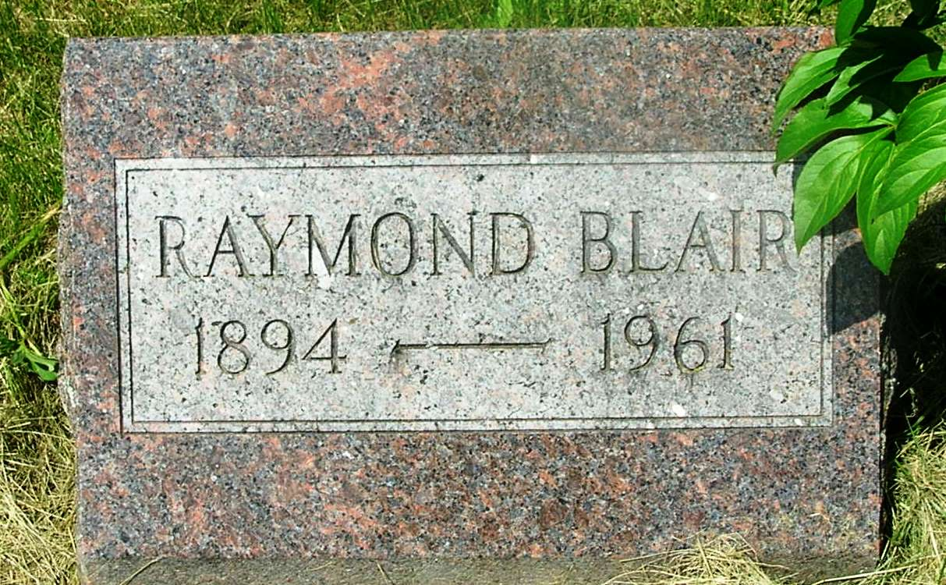

Raymond Blair
in the Indiana, Death Certificates, 1899-2011
Name: Raymond Blair
Gender: Male
Race: White
Age: 67
Marital status: Widowed
Birth Date: 18 Jan 1894
Birth Place: Indiana
Death Date: 8 Nov 1961
Death Place: Bluffton, Wells, Indiana , USA
Father: George M Blair
Mother: Hanna Holloway
Informant: Raymond Eugene Blair; son; Bluffton, Ind.
Burial: Nov. 10, 1961; Stahl Cem., Bluffton, Ind.

