Calvin Zoll
January 25, 1890 – November 5, 1910

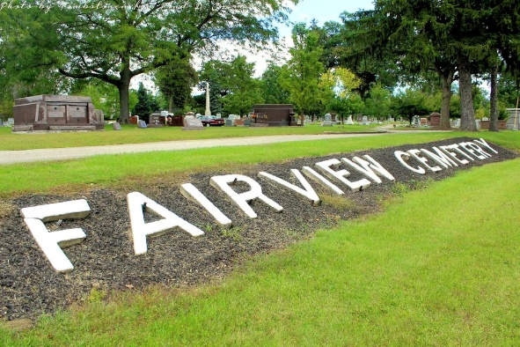
Photo by Tombstoner & Family

ZOLL FUNERAL TODAY
Further Details of Accident That Caused Bluffton Boy's Life
The body of Calvin Zoll, the young man who was killed at the Barber Asphalt Company's plant in Ft. Wayne Saturday morning, was brought to this city Saturday evening and brought to the Zoll residence on Spring Street.
The funeral services were held Monday at two o'clock at the First M. E. Church in this city with the Rev. W. W. Martin in charge and burial took place in the Fairview Cemetery.
Further details of the accident in Ft. Wayne are to the effect that the young man who had been at work only a short time Saturday morning previous to the accident was going about the oiling of the drying machine of the plant. Most of the big wheels were enclosed by a sheet iron casting but there were some exposed cogs, and the young man tried to jump over these and his clothing caught. He struggled to tear himself loose, but his heavy coat would not give and drew him into the cogs. It was necessary to reverse the machine and run it backwards to extricate the body. He was still living but unconscious when taken out, but died within a few minutes. When he went to work Saturday morning, Zoll told his fellow workmen that he had been unable to sleep the previous night because of bad dreams caused by seeing a man by the name of Dolan cut up under a train Friday night at Fort Wayne.

Evening News, Wells County, Indiana
Mon, Nov 7, 1910, p.1 col. 1
**

BLUFFTON MAN KILLED AT FORT WAYNE

FORT WAYNE, Ind., Nov. 5 - J. T. (sic) Zoll, a young man from Bluffton was instantly killed when he fell into the cog wheels of a drying machine at the plant of the Barber Asphalt paving company here, where he was employed. His body was horribly mangled. He was twenty-three years old. A brother, who was working with him, stood within a few feet of him when the accident occurred, but was unable to do anything to save him.

Berne Witness, Adams County, Indiana
Tuesday, Nov. 8, 1910
**

Indiana, U.S., Death Certificates, 1899-2017 (very faded)
Name Calvin Zoll
Gender Male
Race White
Marital Status Single
Age 21
Birth Date Jun
Birth Place Indiana
Death Date 5 Nov 1910
Death Place Fort Wayne, Allen, Indiana, USA
Death Registration Date 1910
Father Edward Zoll, informant
Mother Bulcock
Burial Bluffton, Ind.
**
Calvin Zoll from tree Zoll Family Tree
Birth 25 Jan 1890 Indiana, USA
Residence 1910 Bluffton, Wells, Indiana, USA
Death 5 Nov 1910 Fort Wayne, Allen, Indiana, USA
Father Edward Zoll (1851-1923)
Mother Alice Babcock (1856-1923)
127 People 5 Records 8 Sources

