Betty L. (Smith) Young
February 13, 1926 – October 14, 2017

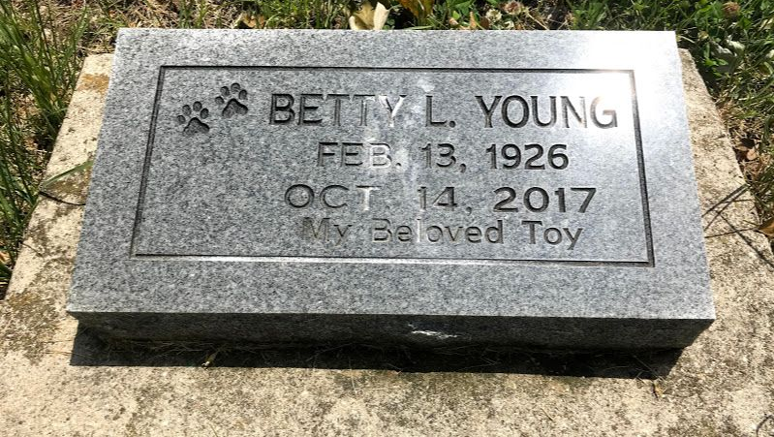
Photo by SMMR

Betty L. Young, 91, of Ossian passed away on Saturday morning, October 14, 2017, at Ossian Health & Rahab Center.
A graveside service will be held at 1:30 P.M. on Wednesday (October 18, 2017) at Fairview Cemetery in Bluffton. Rev. Lyle Breeding will officiate. Funeral arrangements have been entrusted to the care of the Thoma/Rich, Lemler Funeral Home in Bluffton

Thoma/Rich, Lemler Funeral Home, Wells County, Indiana
October 16, 2017
**

Indiana, U.S., Death Certificates, 1899-2017
Name Betty L Young
Maiden Name Smith
Gender Female
Race White
Age 91
Birth Date 13 Feb 1926
Death Date 14 Oct 2017
Death Place Ossian, Wells, Indiana, USA
Death Registration Date 2017
Father Leonard Orville Smith
Mother Hazel Yost Smith
Informant Amnesty Krudop, case worker
Burial Fairview Cemetery
Certificate Number 051568

