Sally Dyan (Olson) Workman
July 15, 1934 – October 21, 2008

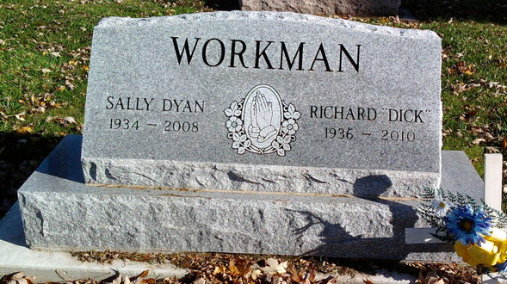
Photo by Thomas Liby

Sally D. Workman, 74, of Bluffton, died at 6:55 p.m. Tuesday, Oct. 21, 2008, at Heritage Pointe in Warren. Born in Madison, Wis., July 15, 1934, to Henry and Ruth E. (Mendenhall) Olson, she married Richard E. "Dick" Workman in Bluffton June 23, 1971. He survives.
Mrs. Workman worked in the laundry department at Meadowvale Care Center for 12 years before retiring in 1996. She also worked at Indiana Glass in Dunkirk and, for 18 years, at Corning Glass Works in Bluffton. She attended Sonlight Church for 25 years.
Also surviving are three sons, Ricky Eugene (Diane) Reynolds of Warren, and Randy Raymond (Laura) Reynolds and Ronnie Dale (Kim) Reynolds, both of Bluffton; two daughters, Rebecca Reane (Charles) Cliffton of Bluffton and Cynthia Rea Blumenhorst of Montpelier; one brother, Bill (Linda) Olson of Rice Lake, Wis.; and 12 grandchildren and 24 great-grandchildren.
She was also preceded in death by two brothers, Eugene and Larry Olson, and one sister, Connie Sterns.
Funeral services will be at 10:30 a.m. Friday, at the Goodwin Memorial Chapel in Bluffton with Tom Bradley officiating. Calling hours will be from 4 to 8 p.m. Thursday at the funeral home. Burial is at Fairview Cemetery in Bluffton.
Preferred memorials are to the Hospice of Northeast Indiana or to the Alzheimer's Association.

Bluffton News-Banner, Wells County, Indiana
Wednesday, Oct. 22, 2008

