Richard E. “Dick” Workman
October 5, 1936 – October 18, 2010

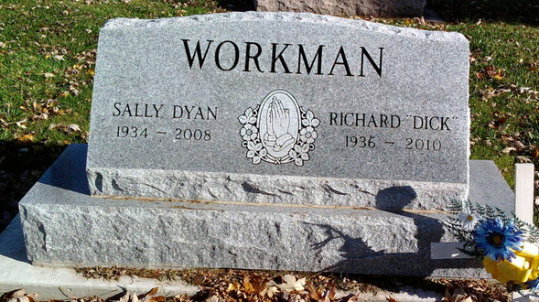
Photo by Thomas Liby

Richard E. “Dick” Workman, 74, of Bluffton, died at 12:12 a.m. Monday, Oct. 18, 2010, at Lutheran Hospital in Fort Wayne. Mr. Workman was born in Bluffton on Oct. 5, 1936, to James and Helen (Stinson) Workman. He married Sally Dyan Olson in Bluffton on June 23, 1971; she preceded him in death on Oct. 21, 2008.
Mr. Workman served in the National Guard. He worked at Corning Glass in Bluffton for 19 years, and Franklin Electric in Bluffton for 10 years before retiring in March, 1999. He attended Sonlight Wesleyan Church, and for many years he enjoyed riding motorcycles with his friends.
Surviving relatives include three step sons, Ricky (Diane) Reynolds of Warren, Randy (Laura) Reynolds of Bluffton and Ronnie (Kim) Reynolds of Winnabaga, Minn.; one step daughter, Rebecca (Charles) Clifton of Bluffton; one daughter, Cheryl Beckstead of Cookville, Tenn.; three sons, Bruce (Cindy) Workman of Mount Vernon, Ill., Joe (Patty) Workman of Mount Vernon, Ill., and Pat (Vickie) Workman of Fairfield, Ill; one brother, Robert (Virginia) Workman of Orland; 32 grandchildren and 20 great-grandchildren.
Mr. Workman was also preceded in death by one step daughter, Cindy Blumenhorst, who died in 2009, and one grandson, Joseph Workman Jr., who died in 2007.
Calling hours will be from 2 to 8 p.m. Wednesday, Oct 20, at the Goodwin Memorial Chapel in Bluffton. Funeral services will be at 10:30 a.m. Thursday, Oct. 21, at the funeral home with Tom Bradley officiating. Burial is at Fairview Cemetery in Bluffton.
Preferred memorials are to the Sonlight Wesleyan Church in Bluffton.

Goodwin Funeral Homes, Wells County, Indiana
October 19, 2010

