Esther Irene (LaTurner) Wolf
January 4, 1882 – May 4, 1924

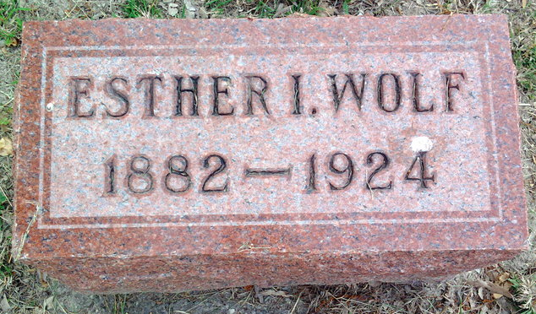
Photo by Thomas Liby

Mrs. Melvin Wolf Dies Sunday Morning
Funeral Services To Be Held At Christian Church Tuesday Afternoon

Mrs. Esther Irene Wolf, 42 years old, wife of Melvin Wolf, 527 Beth
Avenue, died of heart complications Sunday morning at 8 o'clock. She had been sick for over a year.
Born in Lancaster township, she was the daughter of Frank LaTurner and Mrs. Lydia Hey LaTurner, both of whom survive and reside in Bluffton. Her marriage to Mr. Wolf took place June 18, 1898.
The following children were born to their union: Mrs. Inex M. Little, Homer wolf, both of Poneto, Clarence Wolf, United States Navy; Gerald, Ross, Frances, Harley and Crystal, all livng at home. Two sons are deceased.
Brothers and sisters who survive are Ross LaTurner, Mrs. Lori BRENNER, William LaTurner, Mrs. Nicholas Crickmore, all of Bluffton; Mrs. Emma Massin, Monroe, Mich., and Arthur LaTurner of Bluffton. A sister Mrs. Minnie Vargas is deceased.
Herman Hatfield and Doris Wolf are grandchildren.
Mrs. Wolf was a member of the Methodist church.
Funeral services with be held at the Christian church Tuesday
afternoon at 2 o'clock with Rev. Smith in charge. Interment with be at
Fairview.

Bluffton Evening News, Wells County, Indiana
Monday, 5 May 1924, p. 1
**

Indiana, U.S., Death Certificates, 1899-2017
Name Esther Irene Wolf [Esther Irene Turner]
Gender Female
Race White
Marital Status Married
Age 42y 4m 2d
Birth Date 4 Jan 1882
Birth Place Wells County, Indiana
Death Date 4 May 1924
Death Place Bluffton, Wells, Indiana, USA
Father Frank La Turner
Mother Lydia Hey
Spouse Melvin Wolf, informant
Burial Fairview 5/6/1924
**
Indiana, U.S., Marriages, 1810-2001
Name Ester I Laturner
Gender Female; Race White
Birth Place Wells
Marriage Date 18 Jun 1898; Marriage Place Murray, Indiana, USA
Residence Place Wells
Father Frank Laturner
Mother Lidia Hey
Spouse Chancy M Wolfe
Page 288

