Chauncey Melvin Wolf
April 2, 1877 – November 9, 1960

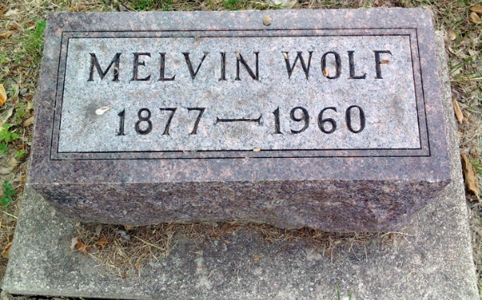
Photo by Thomas Liby

Melvin WOLF, 83, Dies; Ill 7 YEARS

[Chauncey] Melvin WOLF, 83, of 627 South Dougherty St. died at 10:45 a.m. today at the Wells County Hospital. He had been in failing health seven years.
Born April 2, 1877, in Markle, he was the son of Mr. and Mrs. Ambrose Wolf*. A first marriage was to Esther LaTurner, who died in 1921. His second marriage was to Esther Straw who survives.
A member of the First Christian Church, he had resided in Wells County most of his life.
Surviving in addition to the wife; are four sons, Charles of Long
Beach, Calif, Homer and Harley both of Monroe, Mich., and Gerald of
Bluffton, three daughters, Mrs. Inez Little of Monroe, Mich., Mrs.
Crystal Thomas of Detroit, Mich., and Mrs. Frances Bundy of Battle
Creek, Mich.; a brother, Ambrose of Markley; 21 grandchildren and 14
great-grandchildren. A son, Ross, is deceased.
The body is at the Thomas Funeral Home, where friends may call after noon on Thursday. Services will be conducted at 1:30p.m. Friday at the funeral home with Rev. Francis Huffman officiating. Burial will be in the Fairview Cemetery.
*Note from Roberta Wolfe, rwolfe2@voyager.net
“This is in error: C. Melvin Wolf was the son of William Wolf & Mary Louise Baker”

Bluffton News-Banner, Wells County, Indiana
Wed., 9 Nov 1960, Pg. 1

