George Thomas Williamson
March 15, 1841 – February 13, 1914

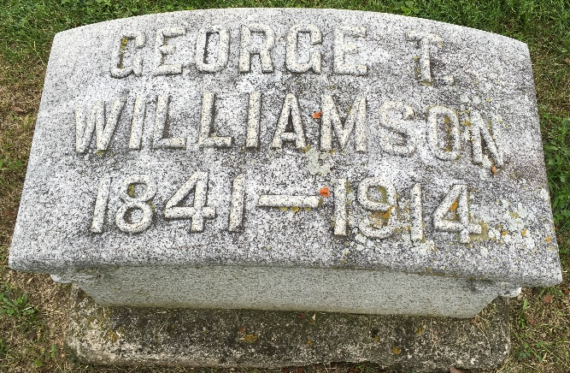
Photo by Barbara Baker Anderson

Indiana, U.S., Death Certificates, 1899-2017
Name George T Williamson
Gender Male
Race White
Marital Status Married
Age 72y 3m 17d
Birth Date 15 Mar 1841
Birth Place Ohio. Farfield County
Death Date 13 Feb 1914
Death Place Bluffton, Wells, Indiana, USA
Death Registration Date 1910-1919
Father Jacob M Williamson
Mother Eliza O'Dell
Spouse Clara Stafford Williamson
Informant Family
Burial Fairview Cem 2/18/1914
**
Indiana, U.S., Marriages, 1810-2001
Name George Thomas Williamson
Gender Male; Race White
Event Type Marriage Registration (Marriage)
Birth Place Fairfield, Ohio
Marriage Date 13 Nov 1894
Marriage Place Bluffton, Indiana, United States
Residence Place Bluffton, Indiana
Father Jacob P Williamson
Mother Eliza Odell
Spouse Clara Susan Stafford
Page 142

