Clara (Stafford) Williamson
August 1, 1859 – October 16, 1945

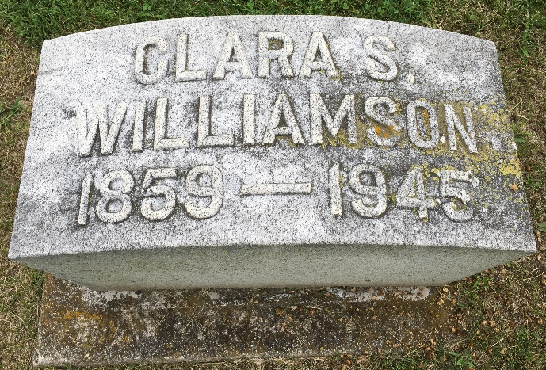
Photo by Barbara Baker Anderson

MRS. WILLIAMSON SUCCUMBS IN OHIO

Mrs. Clara S. Williamson, 86, a former resident of Bluffton and widow of the late George T. Williamson, former Bluffton businessman and banker, died at 8:30 p.m. Tuesday at a hospital at Delaware, O. Her death was caused by complications that followed an illness extending over the past six years. Prior to going to the hospital for treatment, she had been residing with a daughter, Mrs. Ruth Spain, at Richwood, O.
At the time she resided in Bluffton, her husband and his brother, Lent A. Williamson, operated a hardware store on East Market street, and they also assisted in founding the old Wells County bank. Their home, during their residency in Bluffton, was at 411 West Market street, the site of the present home of Dr. and Mrs. Harold Caylor.
Mrs. Williamson was born in Pennsylvania, Aug. 1, 1859, a daughter of Mr. and Mrs. John Stafford, but most of her life was in Bluffton. She was united in marriage to George T. Williamson in Bluffton in 1892. He preceded her in death in 1914.
Mrs. Williamson was a member of the Presbyterian church.
Surviving are a daughter, Mrs. Ruth Spain, of Richwood, O.; a son Jesse Williamson, of Bluffton; a granddaughter, Mrs. John Lybrook, of Bluffton, and a nephew, Earl Merriman, of Kansas City, Mo.
A son, Merle Williamson, and three daughters, Helen, Wilna [sic] and Georgie, are deceased.
The body was returned to the McBride funeral home this afternoon and may be viewed there after 6 o'clock this evening. Funeral services will be held at the McBride funeral home at 2 p.m. Thursday in charge of Rev. A. K. Korteling and burial will be in Fairview cemetery.

Bluffton News Banner, Wells County, Indiana
Wednesday, Oct. 17, 1945

