Annie E. (Kiger) Williamson
December 4, 1853 – May 15, 1886

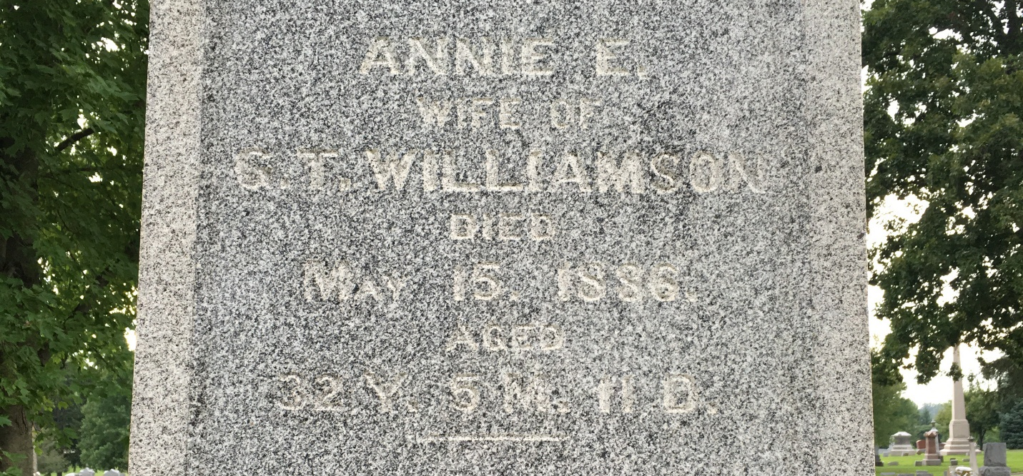
Photo by Barbara Baker Anderson

U.S., Family History Books
Name Ann Kiger
[Ann Hunter]
Gender Female
Birth Date 15 Dec 1853
Birth Place Fairfield County
Marriage Place Fairfield County
Death Date 15 May 1886
Death Place Bluffton, Ind
Father Jesse Hunter
Mother Margaret (Halderman) Kiger
Spouse George Thomas Williamson
Children Merle K Williamson, Wilna Williamson
Title Maryland and Virginia Colonials: Genealogies of Some Colonial Families, Vol I

