John Nicholas A. Williams
August 12, 1857 – October 3, 1936

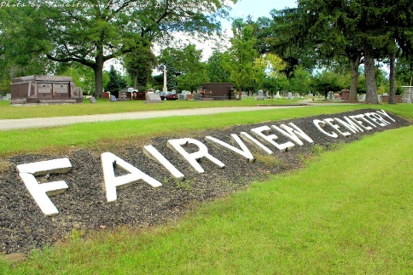
Photo by Tombstoner & Family

WILLIAMS

Bluffton, Oct. 26 - The body of John Williams, a former Bluffton resident who died yesterday at Vincennes, will be brought to this city early Wednesday and funeral services will be held at 11 am at the Thoma Funeral Home.
The Rev. Morris H. Coers will have charge of the services. Burial will be in the Fairview Cemetery.

Fort Wayne Journal-Gazette, Allen County, Indiana
October 7, 1936, Page 7
**

Indiana, U.S., Marriages, 1810-2001
Name John A Williams
Gender Male
Event Type Marriage Registration (Marriage)
Marriage Date 18 Dec 1882
Marriage Place Indiana, United States
Spouse Alice Kover
Officiator J H Orensby
Page 209

