Alice Leah (Kover) Williams
1866 – April 25, 1888

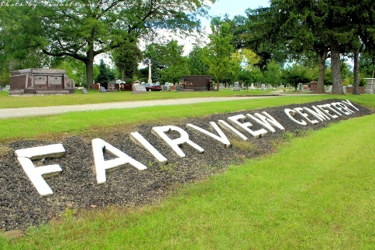
Photo by Tombstoner & Family

Indiana, Marriages, 1810-2001
Name Alice Kover
Gender Female
Event Type Marriage Registration (Marriage)
Marriage Date 18 Dec 1882
Marriage Place Indiana, United States
Spouse John A Williams
Officiator J H Orensby
Page 209
**
Alice Leah Kover from tree Williams/Atkinson Family Tree
Birth 1866 Bluffton, Wells, Indiana, USA
Residence 1880 Bluffton, Wells, Indiana, USA
Marriage 18 Dec 1882 Bluffton, Wells, Indiana, USA
Death 25 Apr 1888 Bluffton, Wells, Indiana, USA
Father Henry Washington Kover (1841-1905)
Mother Henrietta W Drayer Kover (1844-1926)
Spouse Johannes Nicolaus August/John N.A. Levander/Williams (1856-1936)
1766 People 6 Records 11 Sources

