Miriam Kathryn (Edington) Wilhelm
September 13, 1907 – April 30, 1993

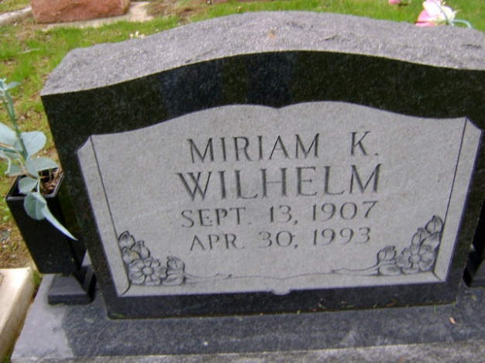
Photo by Bruce Sonner

Indiana, U.S., Marriage Certificates, 1960-2012
Name Miriam Kathryn Gentis
Gender Female
Marriage Age 35
Birth Date 1 Oct 1907
Birth Place Wells, Indiana
Marriage License Date 10 Jun 1943
Marriage Date 10 Jun 1943
Marriage Place Wells, Indiana, USA
Residence Place Wells, Indiana
Spouse Charles L Wilhelm
**

U.S., Social Security Applications and Claims Index, 1936-2007
Name Miriam Kathryn Wilhelm
[Miriam K Wilhelm] [Miriam Kathryn Edington]
Gender Female
Birth Date 1 Oct 1907
Birth Place Bluffton Wel, Indiana
Death Date 30 Apr 1993
Father Hugh F Edington
Mother Belle D Hoovey
SSN xxx
Notes Aug 1963: Name Listed As Miriam Kathryn Wilhelm; 11 May 1993: Name Listed As Miriam K Wilhelm

