Edith Emma (High) Wilhelm
December 27, 1899 – January 18, 1938

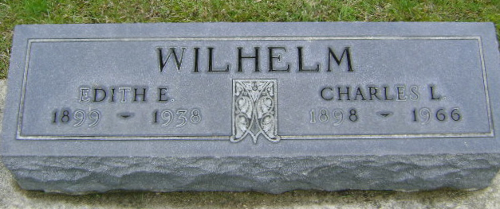
Photo by Bruce Sonner

Indiana, U.S., Marriage Certificates, 1960-2012
Name Edith Emma High
Gender Female
Race White
Marriage Age 25
Birth Date 27 Dec 1899
Birth Place Wells, Indiana
Marriage License Date 1 Jan 1925
Marriage Date 1 Jan 1925
Marriage Place Wells, Indiana, USA
Residence Place Bluffton, Indiana
Spouse Charles Levi Wilhelm
**
Edith High, daughter of Joseph E High and Margaret Gregg, born Dec 1900 in Wells Co.; died Jan 18, 1938, buried Fairview Cemetery at Bluffton. Married Charles Wilhelm Jan. 1, 1925 at Bluffton, Ind.
Descendants of Rudolph Holsinger, Author Holsinger, Paul Gates, 1899- ; p. 257.

