Charles Levi Wilhelm
April 24, 1898 – December 2, 1966

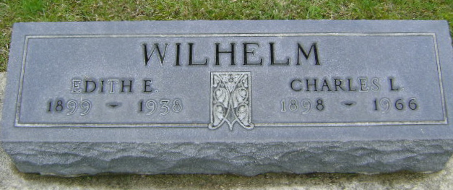
Photo by Bruce Sonner

Ill one day

BLUFFTON – Charles L. Wilhelm, 68, Wells County farmer of R.R. 2, died at 7:15 am Friday in Clinic Hospital.
The wife, formerly Miriam Edington; two daughters, one stepdaughter, 11 grandchildren, one brother survives.
Calling at the Thoma Funeral Home until noon Sunday, then at the First Presbyterian Church prior to 1:30 pm rites.

Journal-Gazette, Allen County, Indiana
December 3, 1966, Page 20B
**

Indiana, U.S., Death Certificates, 1899-2017
Name Charles L Willhelm
Gender Male
Race White
Marital Status Married
Age 68
Birth Date 24 Apr 1898
Birth Place Indiana
Death Date 2 Dec 1966
Death Place Bluffton, Wells, Indiana, USA
Death Registration Date 1966
Father Henry Wilhelm
Mother Lola Ulrich
Spouse Mrs Miriam Willhelm, informant
Burial 12/4/1966 Fairview

