Isabel (Bentz) White
June 25, 1861 – June 2, 1940

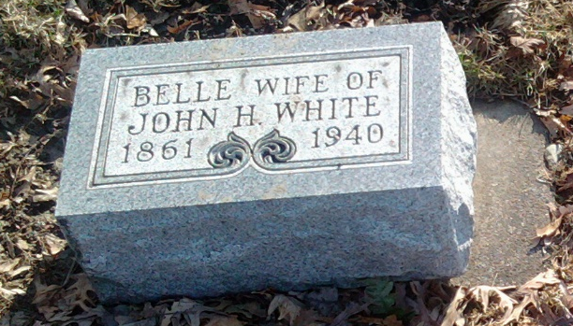
Photo by Thomas Liby

WHITE

Bluffton, June 2 – Mrs. Isabel White, 78, widow of John Henry White, died at 8 am today at the home of a son, Albert White of this city, following an illness of eight weeks. She was a member of the Daughters of Rebekah and Degree of Pocahontas Lodges.
Surviving are two sons, Earl and Albert White, a granddaughter, a great-granddaughter, and two sisters, Mrs. Jacob Sohn of Marion and Mrs. Martin Davis of Indianapolis.
The body was taken to the funeral home of H. Thoma & Son, where funeral services will be held at 2 pm Tuesday in charge of Rev. Matthew Worthman of the First Reformed Church. Burial will be in Fairview Cemetery.

Journal-Gazette, Allen County, Indiana
June 3, 1940
**

Indiana, U.S., Death Certificates, 1899-2017
Name Isbel White [Isbel Bentz]
Gender Female
Race White
Marital Status Widowed
Age 78y 11m 7d
Birth Date 25 Jun 1861
Birth Place Pennsylvania
Death Date 2 Jun 1940
Death Place Bluffton, Wells, Indiana, USA
Father Rudolph Bentz
Mother Mary Welson
Spouse John Henry White
Informant Albert White, Bluffton, IN
Burial 6-4-1940 Fairview

