Virginia E. (Burchett) West
May 12, 1932 – March 22, 2018

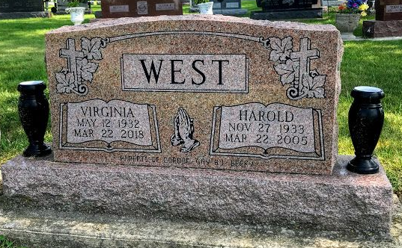
Photo by SMMR

Virginia E. West, 85, of Bluffton, passed away on Thursday morning, March 22, 2018, at Heritage Pointe in Warren.
She was born on May 12, 1932 in Albany, Kentucky to Otis Burchett & Mary (Huddleston) Marks. She graduated from CCHS in 1948 and attended New Castle Business College. Virginia worked at Miller Jones Shoe Company and at Franklin Electric in Bluffton for 38 years and retired in 1995. She also owned and operated West Disposal with her husband Harold, for 18 years. In her retirement she worked at Dewayne’s Sweeper Shop for 12 years. She attended Sonlight Wesleyan Church in Bluffton. Virginia was an avid BINGO player and a talented seamstress and loved and enjoyed spending time with her grandchildren
She married Harold West on Sept. 13, 1955 in Albany, Kentucky and he precedes her in death on March 22, 2005.
Survivors include her daughters Gay (Scott) Schoeff of Travelers Rest, SC. and Becky Markley of Bluffton along with 9 grandchildren, 23 great-grandchildren.
She is preceded in death by her husband Harold, two sons – B.J. West and Gordon West and a brother Les Burchett.
Funeral Services will be held at 3:00 P.M. on Saturday (March 24, 2018) at the Thoma/Rich, Lemler Funeral Home in Bluffton. Rev. Lyle Breeding will officiate. Burial will follow at Fairview Cemetery in Bluffton. Memorials may be made to Family through the funeral home. Calling hours will be held from 10 A.M. to 3 P.M. on Saturday, prior to the service.
Thoma/Rich, Lemler Funeral Home, Wells County, Indiana
March 23, 2018

