Harold West
November 27, 1933 – March 22, 2005

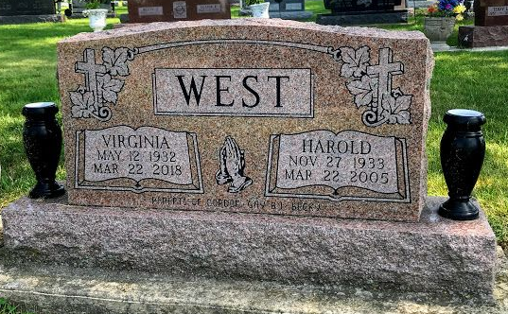
Photo by SMMR

Harold West, 71
Owner of West Disposal Inc. for 22 years until retiring in 1989, Harold West, 71, of Bluffton died at 1:29 a.m. Tuesday, March 22, 2005, at Lutheran Hospital in Fort Wayne. Prior to owning the disposal firm, which had the city of Bluffton contract for a time, he was employed at Franklin Electric for 13 years.
Born November 27, 1933, in Harlan, Ky., he was a son of Walter and Rose Parks West. His marriage was on Sept.13, 1950, at Stoney Creek, Va., to Virginia E. Burchett, who survives. He was a member of the Sonlight Wesleyan Church and the Eagles and Moose Lodge in Bluffton.
Surviving, in addition to his wife, are two sons, J. Gordon West and Bob J. West, both of Bradenton, Fla.; two daughters, Mrs. Scott (Gay) Schoeff and Becky Markley, both of Bluffton; three brothers, Donald Lee West of Bluffton, Charles West of Fort Wayne and Claud West of Decatur; four sisters, Pauline Rothgeb and Mrs. Larry (Bernice) Wine, both of Fort Wayne, and Mrs.Hue (Midge) Ginter and Mrs. Jim (Stella) Masterson, both of Bluffton; nine grandchildren and seven great-grandchildren.
Visitation will be today from 6 to 8 p.m. and Thursday from 2 to 8 p.m. at Goodwin Memorial Chapel, where services will be at 10:30 a.m. Friday with Rev. Tom Bradley officiating.

Bluffton News Banner, Wells County, Indiana
Wed., March 23, 2005

